**BioSIM 11** USER’SMANUAL



**Jacques Régnière**

**Rémi Saint-Amant**

**Ariane Béchard**

**Ahmed Moutaoufik**

**2023**

**Natural Resources Canada**

**Canadian Forest Service**

**Laurentian Forestry Centre**

**P.O. Box 10380, Stn. Sainte-Foy**

**Quebec, QC Canada, G1V 4C7**

**Update to Information Report LAU-X-137**

**Acknowledgements**

BioSIM was developed over a period of several years, and benefited from the contributions of many people, including users, who are too numerous to name here. But special contributions were made by the following people: Lukas Schaubb, Jesse A. Logan, Michael Roden, Barry Cooke, Vincent Bergeron, and Manon Gignac The current version of BioSIM for Windows was conceived and programmed by Rémi Saint-Amant.

The development of BioSIM was made possible with the financial contribution of several Canadian Forest Service partners. In particular, we wish to acknowledge the following members of the SERG-International committee: Forest Protection Limited, Quebec's SOPFIM, the provincial governments of Ontario and British Columbia, and the USDA Forest Service.

Table of Contents

[1 BioSIM Overview 1](#_Toc132704557)

[1.1. Introduction 1](#_Toc132704558)

[1.2. Scientific documentation 1](#_Toc132704559)

[1.3. BioSIM Installation 1](#_Toc132704560)

[1.1.1 Technical support 2](#_Toc132704561)

[1.1.2 Installation 2](#_Toc132704562)

[1.1.3 System requirements 2](#_Toc132704563)

[1.1.4 Utility programs 2](#_Toc132704564)

[1.1.5 Language 2](#_Toc132704565)

[1.4. Running BioSIM 1](#_Toc132704566)

[1.1.6 Graphic user Interface 2](#_Toc132704567)

[1.1.7 Command Line Execution 2](#_Toc132704568)

[1.5. How BioSIM Works 1](#_Toc132704569)

[1.1.8 Required information 2](#_Toc132704570)

[1.1.9 Weather data for simulations 2](#_Toc132704571)

[1.6. BioSIM’s main window 1](#_Toc132704572)

[1.7. Project window 1](#_Toc132704573)

[1.8. BioSIM projects 1](#_Toc132704574)

[2 Weather Data in BioSIM 1](#_Toc132704575)

[1.9. Weather Regime Assembly 1](#_Toc132704576)

[2.1.1 Choice of the nearest sources of weather data 2](#_Toc132704577)

[2.1.2 Adjustment for differences in elevation, latitude and longitude 2](#_Toc132704578)

[2.1.3 Default Continental Gradient 2](#_Toc132704579)

[2.1.4 Correction for slope and aspect 2](#_Toc132704580)

[2.1.5 Generation of daily temperature from monthly normals 2](#_Toc132704581)

[2.1.6 Generation of daily precipitation from monthly normals 2](#_Toc132704582)

[2.1.7 Generation of daily relative humidity and dew point from monthly normals 2](#_Toc132704583)

[2.1.8 Generation of daily wind speed from monthly normals 2](#_Toc132704584)

[2.1.9 Generation of snowfall and snow water equivalent 2](#_Toc132704585)

[2.1.10 Generation of Solar radiation 2](#_Toc132704586)

[2.1.11 Assembly of the regime 2](#_Toc132704587)

[1.10. Generation of hourly weather 1](#_Toc132704588)

[1.11. Linked Data 1](#_Toc132704589)

[2.1.12 Consulting and modifying linked data 2](#_Toc132704590)

[2.1.13 Linked Data Manager, Normals Databases page 2](#_Toc132704591)

[2.1.14 Linked Data Manager, Daily/Hourly Databases page 2](#_Toc132704592)

[2.1.15 Linked Data Manager, Gribs Files page 2](#_Toc132704593)

[2.1.16 Linked Data Manager, Maps Files page 2](#_Toc132704594)

[2.1.17 Linked Data Manager, Models page 2](#_Toc132704595)

[2.1.18 Linked Data Manager, Weather Updater page 2](#_Toc132704596)

[2.1.19 Linked Data Manager, Scripts page 2](#_Toc132704597)

[3 Groups of Components 1](#_Toc132704598)

[4 Defining a Weather Generation 1](#_Toc132704599)

[1.12. Weather Generation Editor 1](#_Toc132704600)

[1.13. Location file 2](#_Toc132704601)

[4.1.1 Location lists file format 3](#_Toc132704602)

[4.1.2 Location File Manager dialog 3](#_Toc132704603)

[4.1.3 Location List Editor dialog 3](#_Toc132704604)

[4.1.4 Location Generator dialog 3](#_Toc132704605)

[4.1.5 Number of points needed to obtain good mapping results 3](#_Toc132704606)

[4.1.6 Generate from a weather database: 3](#_Toc132704607)

[4.1.7 Creating a location list outside of BioSIM 3](#_Toc132704608)

[1.14. Weather Generator input file 2](#_Toc132704609)

[4.1.8 Weather Generator Input File Manager 3](#_Toc132704610)

[4.1.9 Weather Generator (WG) Parameters dialog 3](#_Toc132704611)

[5 Model Execution 2](#_Toc132704612)

[1.15. Model Input File Manager 3](#_Toc132704613)

[5.1.1 Model Input File Manager 4](#_Toc132704614)

[5.1.2 Model specific interface dialog 4](#_Toc132704615)

[1.16. Parameter Variation dialog 3](#_Toc132704616)

[6 Defining Analyses 3](#_Toc132704617)

[1.17. General tab 3](#_Toc132704618)

[1.18. Where tab 4](#_Toc132704619)

[1.19. When tab 4](#_Toc132704620)

[1.20. What tab 4](#_Toc132704621)

[1.21. Which tab 4](#_Toc132704622)

[1.22. How tab 4](#_Toc132704623)

[7 Generating maps (spatial interpolation) 4](#_Toc132704624)

[1.23. Mapping dialog 4](#_Toc132704625)

[7.1.1 Transformation dialog 5](#_Toc132704626)

[7.1.2 Advanced Mapping Options dialog 5](#_Toc132704627)

[1.24. Interpolation methods 4](#_Toc132704628)

[7.1.3 Interpolation method 1: Spatial Regression 5](#_Toc132704629)

[7.1.4 Interpolation method 2: Universal Kriging 5](#_Toc132704630)

[7.1.5 Interpolation method 3: Inverse Weighted Distance 5](#_Toc132704631)

[7.1.6 Interpolation method 4: Thin Plate Splines 5](#_Toc132704632)

[1.25. Displaying mapping results 5](#_Toc132704633)

[8 Running components: Creating the Output Database 5](#_Toc132704634)

[9 Examining Results 5](#_Toc132704635)

[1.26. Data 5](#_Toc132704636)

[1.27. Exporting results 5](#_Toc132704637)

[10 Other components 5](#_Toc132704638)

[1.28. Function Analysis 5](#_Toc132704639)

[10.1.1 Function Analysis dialog 6](#_Toc132704640)

[10.1.2 Analysis Function Test dialog 6](#_Toc132704641)

[1.29. Weather Input Analysis 5](#_Toc132704642)

[1.30. Import a File as a Component 5](#_Toc132704643)

[1.31. Merge 6](#_Toc132704644)

[1.32. Clean Up 6](#_Toc132704645)

[1.33. Weather updater 6](#_Toc132704646)

[1.34. Daily/Hourly Editor 6](#_Toc132704647)

[1.35. Normals Editor 6](#_Toc132704648)

[1.36. Weather Station Matches for Location List 6](#_Toc132704649)

[11 Models in BioSIM 6](#_Toc132704650)

[12 BioSIM Options Dialog 7](#_Toc132704651)

[1.37. BioSIM Options page 7](#_Toc132704652)

[1.38. Directories page 7](#_Toc132704653)

[1.39. Links page 7](#_Toc132704654)

[1.40. Region page 7](#_Toc132704655)

[1.41. Advanced Options page 7](#_Toc132704656)

# BioSIM Overview

## Introduction

BioSIM is a software tool originally designed to assist in the application of temperature-driven simulation models in pest management. Its main purpose was to generate forecasts of features or “events” in the seasonal biology of pests or their host plants. Over the years, its intended use has evolved as the software’s capabilities have progressed in response to the needs of an increasingly diverse user group. These new capabilities have shifted the software’s usage in certain regards and its applications are now rather broad. All of BioSIM’s simulation models are governed by weather conditions (temperature, precipitation, humidity, wind, pressure, snow, and solar radiation). However, recent models can now predict the effects of weather on physical processes (e.g. forest fires) in addition to biological processes (growth and plant productivity, development and performance of pests). BioSIM can also be used as a tool in the development and analysis of such models for purposes of scientific investigation.

BioSIM governs the execution of daily/hourly weather-driven simulation models. It is an integrated environment that provides simulation models with geographically specific weather inputs, functioning either in a historical mode or in a predictive mode (forecast). The software can be used anywhere in the world and for any time period as long as the necessary weather data are available. It can be used to study and predict the course of any process driven by daily weather, whether physical or biological, provided that a simulation model for the organism or process is available. The system can make predictions for specific locations (points) as well as for whole territories when provided with a digital elevation model (DEM) of the area under consideration. These forecasts can form the basis of management plans aimed at the efficient deployment of available resources based on timing or risk, as well as the optimization of control efficacy. Coupled with climate change scenarios, BioSIM can also be used to predict the course of these processes in a changing environment.

The basic functions of BioSIM are to provide geographically adjusted weather inputs, control the execution of simulations and extract information from model outputs for presentation or further analysis. BioSIM assembles weather data from two spatially-referenced databases: the Normals database containing monthly long-term (30-year) weather statistics (e.g. means, variances, correlations) and the observation database containing historical daily/hourly weather records. BioSIM selects the nearest weather stations for each simulation point in a location list, adjusts the data for differences in elevation, latitude, longitude, and restores stochastic variation to long-term normals (a process called disaggregation), when needed. The weather time series sent to the simulation model can be composed of historical or simulated daily/hourly data, or both. What distinguishes BioSIM from other software is its ability to combine actual daily/hourly weather records (including short-term forecasts) and disaggregated normals in a single operation.

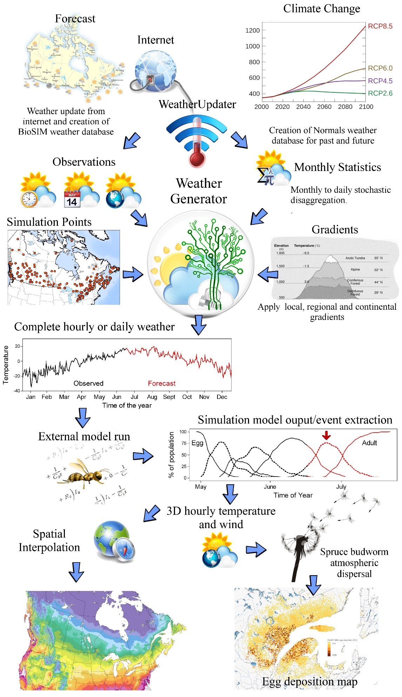

BioSIM provides extensive output analysis functions to summarize model output and present it in the form of tables, or maps. With a digital elevation map (DEM) for the area containing the simulation locations, BioSIM can perform spatial interpolations using various methods (kriging, spatial regression, inverse distance, thin plate splines) and generate output maps (surfaces). Weather generation and model execution are first executed for a series of locations, and outputs are interpolated to produce an output map. Such a map can then be used by itself or in conjunction with other geographically referenced information in the development of ecological insight or of pest management plans.

BioSIM is of interest to any organization responsible for monitoring or managing insect pest populations (forestry, agriculture, horticulture) to plan the timely deployment of sampling or surveying crews and materials (e.g. pheromone traps) without the need for extensive phenology monitoring. Also, it can help time the application of pest control substances for optimal results. Thus, using BioSIM can help optimize the use of pest management resources in a cost-effective manner.

## Scientific documentation

BioSIM has been extensively documented in the scientific literature. A general description of the approach and of the issues surrounding its use can be found in:

Régnière, J. 1996. A generalized approach to landscape-wide seasonal forecasting with temperature-driven simulation models. Environ. Entomol. 25:869-881.

Régnière, J.; Logan, J.A. 1996. Landscape-wide projection of temperature-driven processes for seasonal pest management decision support: a generalized approach. Pages 43-55 *in* T.L. Shore and D.A. MacLean, eds. Decision Support Systems in Forest Pest Management. Proc. Entomological Society of Canada Annual Meeting, October 17, 1995, Canadian Forest Service, Victoria, BC. Canada-BC Forest Research Development Agreement Report No. 260.

Régnière, J.; Cooke, B.; Bergeron, V. 1995. BioSIM: a computer-based decision support tool for seasonal planning of pest management activities. User’s manual. Natural Resources Canada, Canadian Forest Service, Laurentian Forestry Centre, Sainte-Foy, QC. Information Report LAU-X-116.

Régnière, J.; St-Amant, R. 2008. BioSIM 9 User's Manual. Natural Resources Canada, Canadian Forest Service, Laurentian Forestry Centre, Information Report LAU-X-134.

At the heart of BioSIM is a daily weather generator, described in:

Régnière, J.; Bolstad, P. 1994. Statistical simulation of daily air temperature patterns in eastern North America to forecast events in insect pest management. Environ. Entomol. 23:1368-1380.

Régnière, J.; St-Amant, R. 2007. Stochastic simulation of daily air temperature and precipitation from monthly normals in North America north of Mexico. Int. J. Biometeorol. 51:415-430.

It has been applied to plant ecology:

Andalou, C.; Beaulieu, J.; Bousquet, J. 2005. The impact of climate change on growth of local white spruce populations in Québec, Canada. For. Ecol. Manag. 205:169-182.

Beaulieu, J.; Perron, M.; Bousquet, J. 2004. Multivariate patterns of adaptive genetic variation and seed source transfer in *Picea mariana*. Can. J. For. Res. 34: 531-545.

Beaulieu, J.; Rainville, A. 2005. Adaptation to climate change: genetic variation is both a short and a long-term solution. The Forestry Chronicle. 8: 704-709.

Coulombe, S.; Bernier, P.Y.; Raulier, F. 2010. Uncertainty in detecting climate change impact on the projected yield of black spruce (*Picea mariana*). For. Ecol. Manag. 259: 730-738.

Fougère, A.; Girardin, M.P.; Terrier, A.; Grondin, P.; Lambert, M.-C.; Leduc, A.; Bergeron, Y. 2022. Projected changes in fire activity and severity feedback in the spruce-feather moss forest of western Quebec, Canada. Trees, Forests and People. DOI: 10.1016/j.tfp.2022.100229

Girardin, M.P.; Bernier, P.Y.; Gauthier, S. 2011. Increasing potential NEP of eastern boreal North American forests constrained by decreasing wildlife activity. Ecosphere. 2: 1-23.

Girardin, M.P.; Wotton, B.M. 2009. Summer Moisture and Wildfire Risks across Canada. J. Appl. Meteor. Climatol. 48: 517-533.

Govind, A.; Chen, J.M.; Bernier, P.; Margolis, H.; Guindon, L.; Beaudoin, A. 2011. Spatially distributed modeling of the long-term carbon balance of a boreal landscape. Ecol. Modell. 222: 2780-2795.

Guillemette, F.; Bédard, S.; Fortin, M. 2008. Evaluation of a tree classification system in relation to mortality risk in Québec northern hardwoods. The Forestry Chronicle. 84: 886-899.

Hamel, B.; Bélanger, N.; Paré, D. 2004. Productivity of black spruce and Jack pine stands in Québec as related to climate, site biological features and soil properties. Forest Ecology and Management. 191: 239-251.

Houle, D.; Couture, S.; Gagnon. C. 2010. Relative role of decreasing precipitation sulfate and climate on recent lake recovery. Global Biogeochemical Cycles 24 (4).

Le Goff, H.; Flannigan, M.D.; Bergeron, Y. 2009. Potential changes in monthly fire risk in the eastern Canadian boreal forest under future climate change. Can. J. For. Res. 39: 2369-2380.

Michaelian, M.; Hogg, E.H.; Hall, R.J.; Arsenault, E. 2011. Massive mortality of aspen following severe drought along the southern edge of the Canadian boreal forest. Global Change Biology. 17: 2084-2094.

Pedlar, J.H.; McKenney, D.W.; Beaulieu, J.; Colombo, S.J.; McLachlan, J.S.; O’Neill, G.A. 2011. The implementation of assisted migration in Canadian forests. The Forestry Chronicle. 87: 766-777.

Pinno, B.D.; Paré, D.; Guindon, L.; Bélanger, N. 2009. Predicting productivity of trembling aspen in the Boreal Shield ecozone of Quebec using different sources of soil and site information. Forest Ecology and Management. 257: 782-789.

Raulier, F.; Bernier, P.Y.; Ung, C.-H. 2000. Modeling the influence of temperature on monthly gross primary productivity of sugar maple stands. Tree Physiology 20: 333-345.

Riopel, M.; Bégin, J.; Ruel, J.-C. 2011. Coefficients de distribution de la régénération, cinq ans après des coupes avec protection des petites tiges marchandes appliquées dans des sapinières et des pressières noires du Québec. The Forestry Chronicle. 87: 669-683.

Tardif, J.; Girardin, M.P.; Conciatori, F. 2011. Light rings as bioindicators of climate change in interior North America. Global and Planetary Change. 79: 134-144.

Ung, C.-H.; Bernier, P.Y.; Raulier, F.; Fournier, R.A.; Lambert, M.-C.; Régnière, J. 2001. Biophysical site indices for shade tolerant and intolerant boreal species. For. Sci. 47:83-95.

It has been applied to several insects:

Anderson, D. P.; Sturtevant, B.R. 2011. Pattern analysis of eastern spruce budworm *Choristoneura fumiferana* dispersal. Ecography. 34: 488-497.

Bentz, B.; Régnière, J.; Fettig, C.J.; Hansen, E.M.; Hayes, J.L.; Hicke, J.A.; Kelsey, R.G.; Lundquist, J.; Negrón, J.F.; Seybold, S.J. 2010. Climate Change and Bark Beetles of the Western US and Canada: Direct and Indirect Effects. BioScience 60: 602-613.

Bourchier, R.S.; van Herewijk, B.H. 2010. Distribution and potential spread of Japanses knotweed (*Polygonum cuspidatum*) in Canada relative to climate tresholds. Invasive Plant Sci. Manag. 3: 32-39.

Carroll, A.; Régnière, J.; Logan, J.A.; Taylor, S.W.; Bentz, B.J.; Powell, J.A. 2006. Impacts of climate change on range expansion by the mountain pine beetle. Natural Resources Canada, Canadian Forest Service, Pacific Forestry Centre, Victoria, BC. Mountain Pine Beetle Initiative Working Paper No. 2006-14.

Carroll, A.L.; Taylor, S.W.; Régnière, J.; Safranyik, L. 2004. Effects of climate change on range expansion by the mountain pine beetle in British Columbia. 2004. Pages 223-232 *in* T.L. Shore, J.E. Brooks et J.E. Stone, eds. Mountain Pine Beetle Symposium: Challenges and Solutions, October 30-31, 2003, Kelowna, BC. Natural Resources Canada, Canadian Forest Service, Pacific Forestry Centre, Victoria, BC. Information Report BC-X-399.

Cudmore, T.J.; Björklund, N.; Caroll, A.L.; Lindgren, B.S. 2010. Climate change and range expansion of an aggressive bark beetle: evidence of higher beetle reproduction in naïve host tree populations. Journal of Applied Ecology. 47: 1036-1043.

Hansen, E.M.; Bentz, B.J.; Turner, D.L. 2001. Temperature-based model for predicting univoltine brood proportions in spruce beetle (Coleoptera: Scolytidae). Can. Entomol. 133:827-841.

Houle, D.; Duchesne, L.; Boutin, R. 2009. Effects of a spruce budworm outbreak on element export below the rooting zone: a case study for a balsam fir forest. Ann. For. Sci. 66: 707

Logan, J.A.; Macfarlane, W.W.; Wilcox, L. 2010. Whitebark pine vulnerability to climate driven mountain pine beetle disturbance in the Greater Yellowstone ecosystem. Ecol. Appl. 20: 895-902.

Logan, J.A.; Régnière, J.; Powell, J.A. 2003. Assessing the impacts of global warming on forest pest dynamics. Frontiers in Ecology and the Environment 1: 130-137

Logan, J.A.; Régnière, J.; Gray, D.R.; Munson, A.S. 2007. Risk assessment in the face of a changing environment: gypsy moth and climate change in Utah. Ecol. Appl. 17:101-117.

Nealis, V.G.; Régnière, J.; Gray, D.R. 2001. Modeling seasonal development of gypsy moth in a novel environment for decision support of an eradication program. Pages 124-132 *in* A.M. Liebhold, M.L. McManus, I.S.Otvos and S.L.C. Fosbroke, eds. Proc. Integrated Management and Dynamics of Forest Defoliating Insects, August 15-19, 1999, Victoria BC. USDA Forest Service, General Technical Report NE-277.

Pitt, J.P.; Régnière, J.; Worner, S. 2007. Risk assessment of the gypsy moth, *Lymantria dispar* (L), in New Zealand based on phenology modelling. Int. J. Biometeorol. 51:295-305.

Régnière, J.; Bentz, B. 2007. Modelling cold tolerance in the mountain pine beetle, *Dendroctonus ponderosae*. J. Insect Physiol. 53:559-572

Régnière, J.; Nealis, V. 2002. Modelling seasonality of gypsy moth, *Lymantria dispar* (Lepidoptera: Lymantriidae), to evaluate probability of its persistence in novel environments. Can. Entomol. 134:805-824.

Régnière, J.; Sharov, A. 1997. Forecasting gypsy moth flight in the northeastern US with BioSIM. Pages 99-103 *in* Integrating Spatial Information Technologies for Tomorrow, GIS-97 Conference Proceedings, February 18, 1997, Vancouver, BC.

Régnière, J.; Sharov, A. 1999. Simulating temperature-dependent processes at the sub-continental scale: male gypsy moth flight phenology as an example. Int. J. Biometeorol. 42:146-152.

Régnière, J.; Lavigne, D.; Dickison, R.; Staples, A. 1995. Performance analysis of BioSIM, a seasonal pest management planning tool, in New Brunswick in 1992 and 1993. Natural Resources Canada, Canadian Forest Service, Laurentian Forestry Centre, Sainte-Foy, QC. Information Report LAU-X-115.

Régnière, J.; Lavigne, D.; Dupont, A.; Carter, N. 2007. Predicting the seasonal development of the yellowheaded spruce sawfly, *Pikonema alaskensis* (Hymenoptera: Tenthredinidae), in Eastern Canada. Can. Entomol. 139:365-377

Régnière, J.; Nealis, V.; Porter, K. 2007. Climate suitability and management of biological invasions: gypsy moth in Canada. Biol. Invasions 11:135-148.

Régnière, J.; St-Amant, R.; Duval, P. 2010. Predicting Insect Distributions under Climate Change from Physiological Responses: Spruce budworm as an example. Biological Invasions 14: 1571-1586.

Safranyik, L.; Carroll, AL.; Régnière, J.; Langor, D.W.; Riel, W.G.; Shore, T.L.; Peter, B.; Cooke, B.J.; Nealis, V.G.; Taylor, S.W. 2010. Assessment of range expansion of the mountain pine beetle in the boreal forest. The Canadian Entomologist 142: 415-442.

Tobin, P.C.; Sharov, A.A.; Liebhold, A.A.; Leonard, D.S.; Roberts, E.A.; Learn, M.R. 2004. Management of the Gypsy Moth through a Decision Algorithm under the STS Project. American Entomologist. 50: 200-209.

Tobin, P.C.; Van Stappen, J.; Blackburn, L.M. 2010. Human visitation rates to the Apostle Islands National Lakeshore and the introduction of the non-native species *Lymantria dispar* (L.). Journal of Environmental Management. 91: 1991-1996.

Tran, J.K.; Ylioja, T.; Billings, R.F.; Régnière, J.; Ayres, M.P. 2007. Impact of minimum winter temperatures on the population dynamics of *Dendroctonus frontalis* (Coleoptera: Scolytinae). Ecol. Appl. 17:882-899.

## BioSIM Installation

### Technical support

BioSIM is distributed without charge. However, the Canadian Forest Service cannot offer extensive free technical support. Nevertheless, questions may be directed to the developers at the following electronic addresses. For general questions about the usefulness and approach of BioSIM, contact Jacques Régnière at: Jacques.Regniere@NCan-RNCan.gc.ca. For technical issues concerning the installation and use of the software, contact Rémi Saint-Amant at: Remi.Saint-Amant@NRCan-RNCan.gc.ca. Arrangements concerning major support needs may also be made through a mutual agreement between the user, the Canadian Forest Service and the developers of BioSIM. You can contact BioSIM developers by e-mail at the above addresses or by regular mail:

Dr. Jacques Régnière or Rémi Saint-Amant,

Natural Resources Canada

Canadian Forest Service

Laurentian Forestry Centre

1055 du P.E.P.S.

P.O. Box 10380, Stn. Sainte-Foy

Québec (QC) G1V 4C7 Canada

### Installation

BioSIM, documentation, tutorial and demo can be accessed here:

<https://apps-scf-cfs.nrcan.gc.ca/biosim>

Optionally, it’s also available on the FTP:

<ftp://ftp.cfl.scf.rncan.gc.ca/regniere/software/>BioSIM/

The user must download BioSIM11\_x\_x.zip on the destination computer and unzip it somewhere on the computer.

A complete demo with default databases is also provide: DemoBioSIM.zip

Advanced user can also download many databases from the FTP site:

<ftp://ftp.cfl.scf.rncan.gc.ca/regniere/Data11>

Note that FTP link is no longer accessible by web browser like Google Chrome or Microsoft Edge. User must use Windows file explorer or FTP application like FileZilla.

### System requirements

BioSIM is compatible with the Microsoft Windows XP, Windows 7, 8 10 and 11 operating systems, and will run on computers with at least 250 Mb of free hard disk space.

The BioSIM 11 software is parallel capable. It automatically makes full use of multiple-core machines.

### Utility programs

Seven separate programs are provided with BioSIM to make the system’s capabilities more complete (see each utility’s help system for more information on its use):

* NormalsEditor: used to edit Normals databases.
* DailyEditor: used to edit Daily databases.
* HourlyEditor: used to edit Hourly databases.
* MatchStation: to visualise nearest match station and gradients.
* WeatherUpdater: Download and create weather database.

BioSIM can also export analysis outputs to your favourite Windows spreadsheet software (e.g. Microsoft Excel, LibreOffice).

### Language

BioSIM is available in French and English. To change the language, you must select [Tools] [Language] and then click [(French or English)] in the menu bar.

## Running BioSIM

### Graphic user Interface

To start BioSIM, the user must double-click on the BioSIM application  located on the main directory.

### Command Line Execution

BioSIM can be run from a command line (in script mode), using Windows Explorer’s task scheduler. This is very useful when setting up a scheduled task to be run automatically (e.g. every day). When BioSIM is run in command line mode, only the checked components of the project are executed. To execute BioSIM in script mode, use the following syntax:

BioSIM11.exe "ProjectFilePath" -e

where "ProjectFilePath" is the complete path to a BioSIM project file (.biox). Two other options are available –show to show progress dialog and –log logFilePath to output log information.

## How BioSIM Works

### Required information

BioSIM controls the execution of weather-driven simulation models for prediction of seasonal processes. To do so, the system must:

* Provide the simulation model with geographically-specific time series of weather data that include daily/hourly air temperatures (minimum and maximum), precipitation, dew point, relative humidity, wind speed and wind direction, snowfall, snow accumulation and snow depth, atmospheric pressure, or solar radiation.
* Control the execution of the selected (highlighted) simulation model(s), optionally varying certain model parameter values.
* Merge all outputs into a database.
* Examine model outputs to extract user-specified statistical features, and present this information in the form of tables or maps.

Seven sources of input can be provided to BioSIM:

* Weather data (accessible through the Linked Data Manager)
  + Normals (monthly statistics)
  + Daily data (including forecasts)
  + Hourly data (including forecasts)
  + Gribs data (weather in map format)
* Input Maps (DEM’s) (accessible through the Linked Data Manager)
* Models (accessible through the Linked Data Manager)
* Model Input (specific to each model and accessible through the Model Editor’s *Input* tab)
* Weather Input (accessible through the Weather Generator Input Editor)
* Location lists (accessible through the Locations File Editor)

A specific extension is associated to each of these input files:

|  |  |  |  |
| --- | --- | --- | --- |
| Type of data | File extension | Subdirectory of the project | Can be stored in global directories |
| Normals weather | .NormalsDB | \Weather\ | Yes |
| Daily weather | .DailyDB | \Weather\ | Yes |
| Hourly weather | .HourlyDB | \Weather\ | Yes |
| Gribs weather | .Gribs | \Weather\ | Yes |
| DEM | .tif | \MapInput\ | Yes |
| Model | .mdl | \Models\ (under root) | Yes |
| Model input | (specific to a model) | \ModelInput\ | No |
| Weather input | .wgs | \WGInput\ | No |
| Location list | .csv | \Loc\ | No |
| Model input variations | (specific to a model) | \ParametersVariations\ | No |

### Weather data for simulations

One of the most crucial and time-consuming steps in implementing BioSIM is the development of the weather databases used by the system. There are three types of weather databases: Normals, Daily and Hourly (which include forecasts). All temperatures in BioSIM databases are in °C. Precipitation is in mm of water. Dew point is in °C and relative humidity is in %. Wind speed is in km/h and wind direction in °. Snowfall and snow accumulation are in mm of water, snow depth in cm. Pressure in hPa and solar radiation is in watt/m².

BioSIM assembles weather data for weather generation at each point in the supplied location list from one or many geographically-referenced databases.

**Normals Database:**

The Normals Database contains long-term (30-year) monthly statistics that are updated on a decadal cycle. Several Normals databases (e.g. the most recent update of North American normals Canada-USA 1991-2020, Central and South America, Europe and the World) are available at:

<ftp://ftp.cfl.scf.rncan.gc.ca/regniere/Data11/Weather/Normals/>.

Databases taking into account climatic change predictions are available at:

<ftp://ftp.cfl.scf.rncan.gc.ca/regniere/Data11/Weather/Normals/ClimateChange>.

Requests for personalised databases can be made to the [development team](#_Technical_support).

**Daily and Hourly Database:**

Observed daily/hourly weather data up to the current day are contained in a Daily/Hourly Database. Forecasts can also be included in the Daily/Hourly Database and are used when short-term weather predictions are needed to obtain more accurate model forecasts (such as during pest control operations using pesticide applications). Several Daily databases are available at:

<ftp://ftp.cfl.scf.rncan.gc.ca/regniere/Data11/Weather/Daily/>.

And several Hourly databases are available at:

<ftp://ftp.cfl.scf.rncan.gc.ca/regniere/Data11/Weather/Hourly/>.

Please note that a Canadian Daily and Hourly database containing weather data for the last two years is available and is updated frequently (usually daily).

Each source of weather data in these databases (a weather station) is georeferenced (latitude, longitude, elevation). BioSIM selects the “best” sources of weather data for each point in the location list, adjusts the data for differences in elevation, latitude and longitude, and generates daily/hourly values by restoring stochastic variation to long-term monthly averages on the basis of local normals (see literature on this process). The weather time series sent to the model execution can be composed of daily/hourly data whenever available (or requested), forecasts for short-term prediction (when available), and normals for prediction of processes under “usual” or “normal” conditions over the longer term or to fill gaps in observed weather.

## BioSIM’s main window

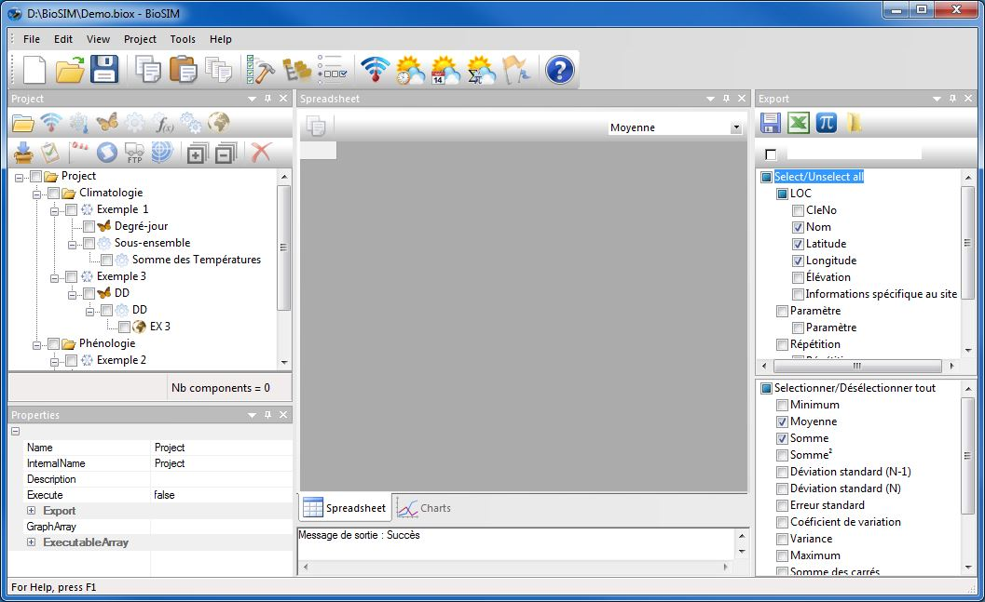

**Main window**:

Show the results of the selected component.

**Export window**: Send the results of the current component outside of BioSIM. Select the variables and the statistics to be exported.

**Properties window**:

Show the properties of the current component.

**Execute Message Log window**:

Show notifications concerning the last execution.

**Project window**: Add a new component to the project.

**Project window**: Add a new component to the project

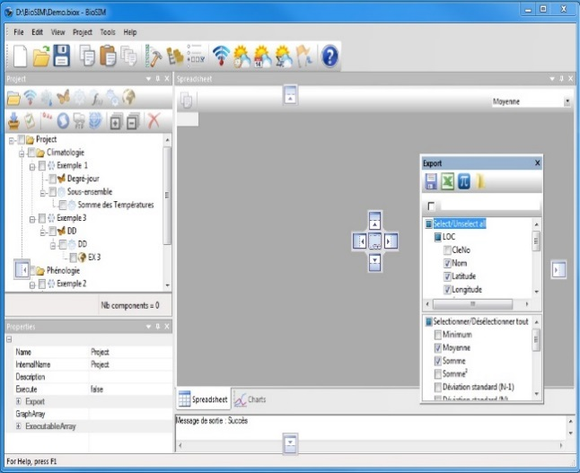The main window’s toolbar buttons contains the usual Windows functions for editing, opening, saving, or cut and paste. Many of the buttons, however, are specific to BioSIM. Their use is explained in the following pages.

The main window of BioSIM is the Execute Message Log. There are four secondary windows docked to the main window: Project, Properties, Data and Export that can be moved around and closed at will.

The four secondary windows can be configured by the user. When a secondary window is moved/dragged using the mouse, two pictograms appear on screen; one surrounding the main window, and one in the main window (Fenêtres_principale) or in whichever secondary window (Fenêtres_secondaire) the user is attempting to drag the first secondary window. These pictograms highlight the area where the secondary window currently being dragged will be docked once it is released. The secondary windows can also be left free (undocked).

All secondary windows can be grouped together in a single window docked to the main window and become accessible as tabs in this window.

Once it has been closed, a secondary window can be reopened by selecting [View] [Toolbars and Docking Windows] from the menu bar.

The Project window lists all the components of a project. It is through this window that the user can add, remove and edit project components. All tabs and windows in BioSIM are linked to the component selected (highlighted) in the Project window. A project is composed of a set of components that can be grouped together in subsets. When a component is selected in the Project window, all other tabs and windows are updated with the information concerning this component.

When a component is executed, using the Execute Checked  button on the main window’s toolbar, the Main window shows the numerical results of the component in question.

The Properties window shows the internal parameters of the component. The Execute Message Log window shows the last execution notifications. The Export window shows all the variables that where selected for export (regardless of their dimension).

## Project window

The Project window’s toolbar is made up of two rows of buttons.

The first row contains buttons that allow the user to add various components to a project, they are:

** Add** **Group**: group components into sub-projects.

** Add Weather Updater:** create and update weather data project.

** Add Weather Generation:** create weather for locations and generate hourly or daily weather from observation or stochastic disaggregation or a mix of both.

** Add Model Execution:** execute models to transform weather into model-specific output (models are in fact external dll’s or exe’s). For example, the spruce budworm seasonality model transforms weather into spruce budworm life-stage development.

** Add Analysis:** based on the output of another component (weather generation, model execution, etc.), this creates a subset of the results of this component and/or extracts information such as time transformations, events or statistics.

**Add Function Analysis**: executes row calculations based on a formula.



** Add Merge**: merges several components of a group to create a single component.

** Add** **Mapping**: adds a mapping component to a parent component (e.g. a weather generation, model execution, etc.). Performs spatial interpolations to create maps from data points on the basis of a DEM (Digital Elevation Model).

An unlimited number of child components can be added to parent components allowing the user to create chains of varying length and composition within each project. However, depending on the nature of the parent component, it is possible that only certain types of child components can be added.

The following table lists the possible parent-child combinations; it must be read by column only and reads as follows: “The component of the column header (child) can (or can’t) be added to the component of the row header (parent)”.

|  |  |  |  |  |  |  |  |  |  |  |  |
| --- | --- | --- | --- | --- | --- | --- | --- | --- | --- | --- | --- |
|  | | **Child** | | | | | | | | | |
|  |  |  |  |  |  |  |  |  |  |
| **Parent** |  | Yes | Maybe\* | Maybe\* | Maybe\* | Maybe\* | Maybe\* | Maybe\* | Maybe\* | Maybe\* | Yes |
|  | Yes | No | No | No | No | No | No | No | Yes | Yes |
|  | Yes | No | No | Yes | Yes | Yes | Yes | Yes | Yes | Yes |
|  | Yes | No | No | Yes | Yes | Yes | No | Yes | Yes | Yes |
|  | Yes | No | No | Yes | Yes | Yes | No | Yes | Yes | Yes |
|  | Yes | No | No | Yes | Yes | Yes | No | Yes | Yes | Yes |
|  | Yes | No | No | Yes | Yes | Yes | No | Yes | Yes | Yes |
|  | Yes | No | No | Yes | Yes | Yes | No | Yes | Yes | Yes |
|  | Yes | No | No | Yes | Yes | Yes | No | Yes | Yes | Yes |
|  | Yes | No | No | Yes | Yes | Yes | No | Yes | Yes | Yes |

\* Because a group **** automatically takes on the type of its parent component, the Maybe in the first row of the table indicates that it might or might not be possible to add a certain type of component to a group. The user must always keep in mind that it is possible to add a component to a group only if it is possible to add this same component to its parent.

For example, if a group **** child is added to an analysis **** parent, it is still possible to add a group ****, a model execution ****, an analysis ****, a function analysis **** or a mapping **** to this group. However, it is no longer possible to add a Weather updater****, a Weather generation **** or an input weather analysis.

It is easy to recognise when certain types of components cannot be added into others because the buttons on the first row of the Project window’s toolbar automatically become greyed for the current (highlighted) component.

The second row of the Project window’s toolbar contains the following buttons:

** Add** **Import File**: imports data from an external .csv file.

**Add Input Weather Analysis**: can only be performed on a Weather Generation, and is used to examine weather information.



**Add Dispersal:** simulate the dispersal of insects by the wind.



**Add script:** to run a R script.



**Copy Export:** copy export to an other directory or an FTP site.



**Add model calibration:** calibrate parameters of external model.



 **Add curve calibration:** calibrate, development rate, survival, and fecundity function.

** Expand All**: expand all sub-components (children) of a parent component.

** Collapse All**: collapse all sub-components (children) of a parent component.

** Remove**: remove current (highlighted) component and all of its sub-components (children) from the project.

Please note that in the Project window, an existing component can be modified by double clicking on it.

## BioSIM projects

BioSIM stores information on components (weather generation, model execution, analyses, etc.), location lists files, input parameter files, and other specifications in “projects”. Each project is stored in a distinct project directory, composed of a project definition file with the extension .biox, and several subdirectories.

The user must select a location in which to store BioSIM projects. For example, “C:\MyDirectory\BioSIM\” where “C:\MyDirectory\” is the user’s selected path. Projects can be stored in any location on the disk but it is good practise to store each project in a distinct project directory with the same name as the project itself.

For example, if a project file is named DemoBioSIM.biox, the directory name in which it is stored should be “DemoBioSIM”. In this case, the directory structure would be as follows:

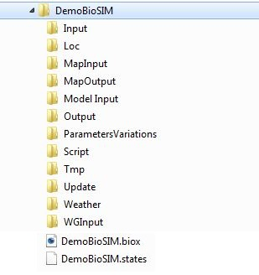

External data files

Location lists

Project-specific DEM’s

Output maps

Model input parameters

Analysis outputs (export files)

Specific model-parameter variations

BioSIM scripts

Internal component results (for internal BioSIM use)

Weather updates

Project-specific weather databases

Weather generator specification

Project file (.biox)

All \*.biox files are in XML format. Because an XML file is an editable text file, advanced users can edit .biox files directly.

**Creating a new project**

To create a new project in BioSIM, the user must open the software and select [File] [New] from the menu bar. To open an existing project, the user must select [File] [Open] from the menu bar. BioSIM also starts and opens a project file that is double-clicked from Windows Explorer.

# Weather Data in BioSIM



## Weather Regime Assembly

BioSIM can function in one of two modes: Normals or Observations.

|  |  |  |
| --- | --- | --- |
| Mode | Weather Database used | Description |
| Normals (monthly, with daily or hourly  disaggregation) | Normals database only | Used to predict processes based on “usual” weather or under climate change scenarios.  When a specific, actual daily/hourly time series is not important, or available.  Note that even if the normals database contains monthly values, BioSIM automatically generates daily/hourly time series. |
| Observations | Daily/Hourly database, Gribs file and if needed Normals database (to fill missing values and forecast into the future). | Used to predict processes under specific, actual conditions. When exploring the relationship between weather and the actual (past or near-future) outcomes of processes. |

Whether in Normals or in Observations mode, BioSIM functions in much the same way (only the weather databases used to provide models with input change).

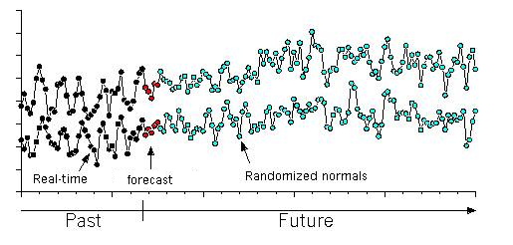

For each model run, BioSIM assembles an input weather regime consisting of a daily/hourly time series of weather variables. Depending on the model, one or several of the following variables may be used: minimum and maximum air temperatures (C), precipitation (mm), dew point (°C) and relative humidity (%), wind speed (km/h) and wind direction (°), pressure (hPa), snowfall and snow water equivalent (mm of water), snow depth (cm) and solar radiation (watt/m²) for one or several years. These data are assembled from stations in weather databases, Normals and Daily/Hourly Databases (which include forecasts).

In assembling this weather regime, BioSIM goes through the following steps:

* Choice of the nearest Daily/Hourly stations for each year (when in Observations mode)
* Choice of the nearest Normals stations (always)
* Adjustment for differences in elevation, latitude and longitude.
* Generation of daily/hourly values from monthly normals (when needed)
* Assembly of all weather
* Temperature adjustment for heating caused by exposure (slope and aspect)

The next section describes each of these steps in detail.

### Choice of the nearest sources of weather data

The choice of nearest weather stations for a given simulation point is made by category of weather information (temperature, precipitation, humidity, wind) and (for observed data) by year. The nearest distance is computed as *cartesian distance:* the nearest station(s) are selected on the basis of the straight-line distance *d* between simulation point and weather station. Differences in latitude (X), longitude (Y) and elevation (Z) are all in km. Elevation is given 100× more weight because of its profound effect on temperature and precipitation (for temperature, a 100 km difference in latitude is roughly equivalent to 0.1 km in elevation):

**

The number of stations of each type (Normals and observation) matched with each location can be set by the user (BioSIM recommends 4-8). The stations selected from each databases are independent.

After adjustment for differences in elevation, latitude and longitude (see below for explanation) between the simulation point and weather stations, data (monthly means or daily/hourly values) are a weighted average with 1/*d*² as weight. Note that daily/hourly values are weighted on a daily/hourly basis. The weighting takes into account the presence of missing data in observation station records.

### Adjustment for differences in elevation, latitude and longitude

Whenever a difference in elevation, latitude, longitude or distance-to-shore exists between the simulation point and the sources of weather data (weather stations), BioSIM adjusts data by applying climatic gradients. Climatic gradients (for minimum and maximum temperatures and precipitation) are computed for each simulation point. Local monthly gradients are obtained from a multiple linear regression equation fitted to the monthly minimum and maximum temperature and precipitation observations from the 25 nearest stations in the Normals Database. The regression equation is:

*Tmin*, *Tmax* or *Precip* = *a* + *b Elev* + *c Lat* + *d Lon*

where *b*, *c* and *d* are gradients (*b* is in °C/km, *c* in °C/1000km and *d* in °C/1000km for temperature,  mm/km, mm/1000km and mm/1000km for precipitation).

When the elevation of the simulation point is too different from that of the nearest stations (distance between the simulation point and the center of mass among the 25 nearest stations), BioSIM blends these local gradients with regional gradients obtained by fitting the regression equation to data from the 75 stations nearest to the simulation point. If this difference is still too big, BioSIM blends with default continental gradient.

### Default Continental Gradient

There are four zones with different default continental gradients:

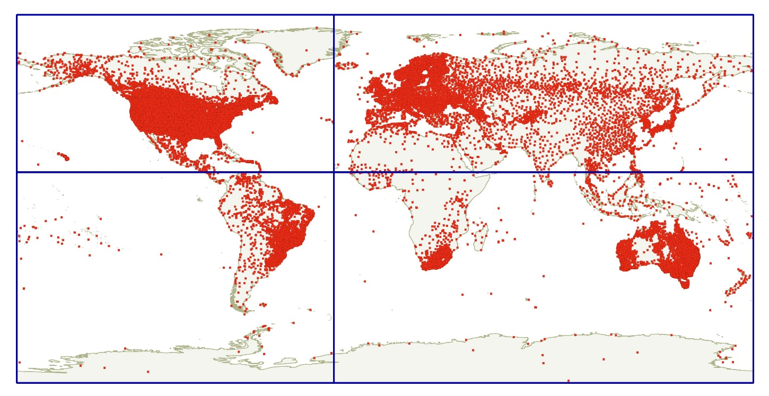

### Correction for slope and aspect

If the simulation point’s slope and aspect coordinates are non-zero, an overheating factor is applied to maximum daily temperatures. This overheating factor depends on the type of surface being modeled (its albedo). By default, BioSIM uses a conifer canopy, where overheating by sunlight leads to maximum temperatures exceeding observed maxima by at most 4°C with a summertime daily range of 20°C, corresponding to the effect of bright sunlight on a forested canopy. It is assumed that all weather stations in the weather databases are on level ground. For mathematical details of this adjustment, see [Régnière (1996)](#Regniere1996).

### Generation of daily temperature from monthly normals

BioSIM interpolates linearly between monthly mean temperatures to produce expected daily normal (mean) minimum and maximum temperatures. Addition of daily fluctuations to input temperature regimes is necessary to simulate the development of cold-blooded animals and plants, because of the so-called Kaufmann effect (Worner, S.P. (1992) Performance of phenological models under variable temperature regimes: consequences of the Kaufmann or rate summation effect. Environ. Entomol. 21: 689-699, Doi: [10.1093/ee/21.4.689](https://doi.org/10.1093/ee/21.4.689)), and to include the occurrence of extremes in simulations. Biological responses to temperature are notoriously non-linear. That is true even with so-called linear degree-day models, as the main source of non-linearity occurs around threshold temperatures. Fluctuations of temperature across thresholds result in a net acceleration of development (warm temperature accelerates development more than cool temperature decreases it). Thus, simulations based on normals (mean temperatures) underestimate development compared with actual (fluctuating) temperatures. The need for stochastic variation in normals was discussed in Régnière & Bolstad (1994). The method used in BioSIM to generate daily values from monthly statistics is described in [Régnière & St-Amant (2007)](#RegniereStAmant2007).

### Generation of daily precipitation from monthly normals

Monthly precipitation normals (average and variance) are used to generate simulated daily precipitation, which is distributed stochastically within each month according to the daily range of temperature. The higher the range, the less likely it is that precipitation will occur. If the simulator predicts precipitation on a given day, the amount is also inversely proportional to the day’s temperature range. Total simulated monthly precipitation is also a random variable determined from the mean total (normal) and its variance (also contained in BioSIM’s Normals Databases). The details of daily precipitation generation from monthly normals by BioSIM are given in [Régnière & St-Amant (2007)](#RegniereStAmant2007).

### Generation of daily relative humidity and dew point from monthly normals

Relative humidity normals in BioSIM are 12 monthly averages  (*r* is daily relative humidity/100, with 0 ≤ *r*≤ 1) and 12 monthly (standard deviations of *r*). Daily stochastic values of *r* are generated using the Beta distribution:

 [1]

where

 [2]

The physics for dew point calculations were taken from Whiteman, CD (2000) Mountain meteorology: Fundamentals and applications. Oxford University Press, NY. P 302-305. After a few simple algebraic transformations from fundamental thermodynamics, dew point (temperature in ºC) is given by:

 [3]

where *T* is air temperature (ºC), Rv = 461 J/ºK/kg is the gas constant of water vapor, L = 2.5×106 J/kg is the latent heat of water over water (when there is no sublimation from vapor to ice), and *r* is relative humidity/100 as defined above.

### Generation of daily wind speed from monthly normals

Wind speed normals in BioSIM are 12 monthly averages  and standard deviations  of =ln(daily mean wind speed, in km/h). Stochastic daily wind speed values *w* (km/h) are generated at random from the log-normal distribution:

 [4]

### Generation of snowfall and snow water equivalent

This module was calibrated from locations in Canada, from Brown et al. 2003 (Brown RD, Brasnett B, Robinson D (2003) Gridded North American monthly snow depth and snow water equivalent for GCM evaluation. Atmosphere and Ocean 41: 1-14). For locations above 30°N in North America (between -180° and -50°E), the temperatures at which precipitation falls as snow and at which snow melts are functions of longitude:

 [5]

 [6]

(longitude expressed in decimal degrees East, negative in the western hemisphere, positive in the eastern hemisphere). For any point outside of this range, *Tsnow*= -0.519 and *Tmelt*=-8.062 are used.

### Generation of Solar radiation

The amount of solar radiation is calculated by a module extracted from MTCLIM Version 4.3 (Peter Thornton, Numerical Terradynamic Simulation Group, School of forestry, University of Montana, Missoula, MT, USA), at [http://www.ntsg.umt.edu/project/mtclim](http://www.ntsg.umt.edu/project/mt-clim.php).

### Assembly of the regime

Weather regimes are assembled in the following manner. First, adjusted and weight-averaged daily randomized normals fill the daily times series of needed weather variables. Then, if any daily data (including forecasts) are to be used and are available, they are adjusted, weight-averaged and replace randomized normals. Thus, any missing values in the daily observations and future weather (beyond forecasts) remain filled with randomized normals.

### Generation of hourly weather

Hourly weather is computed from daily values.

## Linked Data

There are six types of data that can be linked to BioSIM:

* **Normals weather**
* **Daily weather**
* **Hourly weather**
* **Gribs weather**
* **Input Maps (DEM’s)**
* **Models**

Normals databases, Daily/Hourly databases, Gribs and input maps can reside in different directories. These files can be global to all projects or can be local to one project. All of them can be stored either in local (project-specific) or in global directories. Local weather data must be placed in the “Weather” subdirectory of the project and local input maps (DEM’s) must be placed in the “InputMap” subdirectory of the project. These subdirectories are always searched first (by default) and do not need to be specified. Global directories are specified with the *Directories* page of the Options dialog, which can also be used to modify the list of directories in which BioSIM should look for weather databases and DEM’s.

The global weather directories apply to all BioSIM projects and changing them will affect the source of weather data used in all subsequent weather generation. The user should verify that the weather directories are set properly before running models. The same applies to DEM’s.

If several files bear the same name (in different directories), BioSIM lists them all in the lists used to choose among them, but can only access the first one found, which depends on the order in which directories are searched. Project subdirectories are always searched first, and global directories are searched in the same order as they appear in the corresponding directory list.

### Consulting and modifying linked data

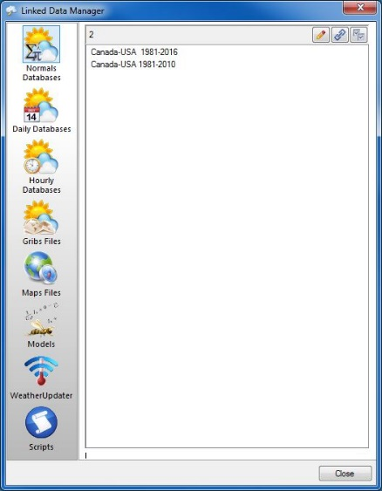In the Linked Data Manager’s dialog each tab is used to select the type of data the user wants to consult or modify: Normals Bases_de_données_normales, Daily data Bases_de_données_quotidiennes,Hourly data ,Gribs files , Input maps (DEMs) Cartes_d'intrans, Models Modèles, Weather updater , or Scripts  .

The main list field of each tab lists all the files (databases) found for the requested type of data. If the file the user is searching for does not appear in the appropriate list, it must either be linked (Link_A_Database) into the Linked Data Manager, or copied into a directory that is already linked to BioSIM.

The user can change the Weather or Input Maps (DEMs) directories that are linked to BioSIM via the *Directories* page of the Options dialog ().

The read-only field at the bottom of the Linked Data Manager dialog always shows the full name and path of the selected file (database).

### Linked Data Manager, Normals Databases page

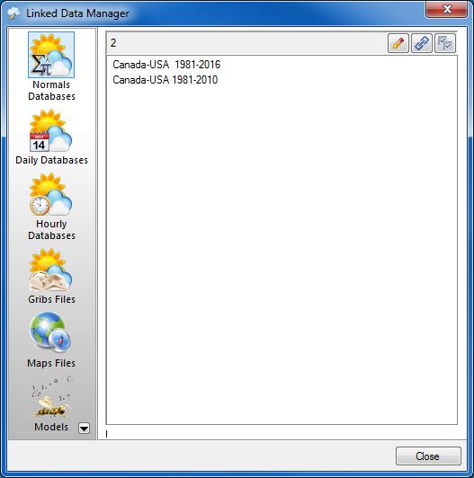

In BioSIM, normals are long-term monthly statistics calculated over 30-year Standard Normal Generating Periods (SNGP), the latest being 1991-2020. These statistics apply to each single weather station in the database. A Normals Database contains these monthly statistics for a number of stations, along with the spatial coordinates of each station (latitude, longitude and elevation).

All Normals Databases (.NormalsDB) located in one of the weather data directories (global or in the project’s \Weather\ subdirectory) are listed in the Linked Data Manager dialog’s *Normals Databases* page list field. The project's \Weather\ subdirectory is always searched first.

Buttons specific to the *Normals Databases* page are as follows:

Modèles_Edit Edit: When a database is selected (highlighted) in the list field, clicking on the Edit button opens this database in the Normals Database Editor application.

Lier_une_base_de_données Link a New File: Add the directory in which the new file is located to the directory list.

Ouvrir_le_dialogue_d'options Open Options dialog: Opens the Options dialog on the *Directories* page in which the user can add and remove links to various directories or simply see the paths to them.

For additional details on Normals databases in BioSIM please refer to the “Normals Data and Normals Data Editor” document.

### Linked Data Manager, Daily/Hourly Databases page

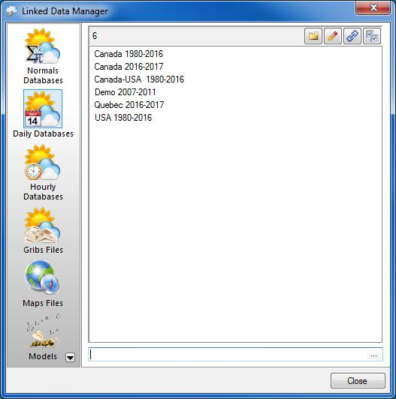

Daily/Hourly databases are used to run BioSIM in the “real world’’, meaning from daily weather records rather than from randomized normals. In addition to simulating historical weather, daily/hourly/hourly data are used in short-term (e.g. seasonal) forecasting (planning) using the most current weather records. Short-term forecasting requires a daily database that is as up to date as possible. Updating such near-future forecasts implies the maintenance (update) of daily databases.

All Daily/Hourly Databases (.DailyDB/.HourlyDB) located in one of the weather data directories (global or in the project’s \Weather\ subdirectory) are listed in the Linked Data Manager’s *Daily/Hourly Databases* page list field. The project's \Weather\ subdirectory is always searched first.

NOTE: When available, weather forecasts can be added directly in the daily/hourly data files. As for daily/hourly data, forecasts apply to a specific location (or “station”).

Buttons specific to the *Daily/Hourly Databases* page are as follows:

Nouveau New: Create a new database. When the user creates a new database, BioSIM asks for the location in which to place the new database. This location can either be the current project's \Weather\ subdirectory or a linked global directory. Next, BioSIM asks for the name of the new database. Usually the name must be meaningful. As a rule, the area and period (e.g. UtahArea\_1921-2001) are used to name Databases.

Éditer Edit: When a database is selected (highlighted) in the list field, clicking on the Edit button opens this database in the Database Editor application.

Lier_une_base_de_données Link a New File: Add the directory in which the new file is located to the directory list.

Ouvrir_le_dialogue_d'options Open Options dialog: Opens the Options dialog on the *Directories* page in which the user can add and remove links to various directories or simply see the paths to them.

For additional details on Daily databases in BioSIM please refer to the “Daily Data and Daily Data Editor” document.

### Linked Data Manager, Gribs Files page

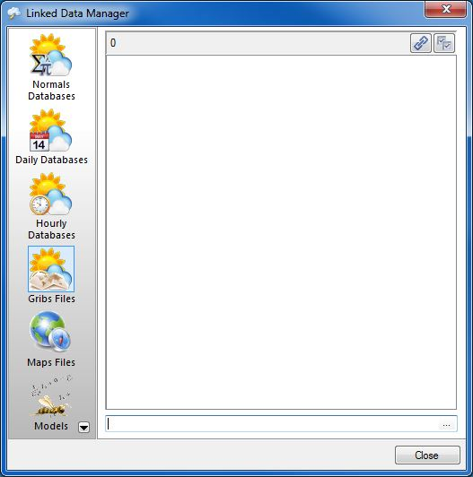

Gribs Files are used to run BioSIM from gridded meteorological data.

All Gribs Files (.Gribs) located in one of the weather data directories (global or in the project’s \Weather\ subdirectory) are listed in the Linked Data Manager’s *Daily Databases* page list field. The project's \Weather\ subdirectory is always searched first.

Buttons specific to the *Gribs* page are as follows:

Lier_une_base_de_données Link a New File: Add the directory in which the new file is located to the directory list.

Ouvrir_le_dialogue_d'options Open Options dialog: Opens the Options dialog on the *Directories* page in which the user can add and remove links to various directories or simply see the paths to them.

### Linked Data Manager, Maps Files page

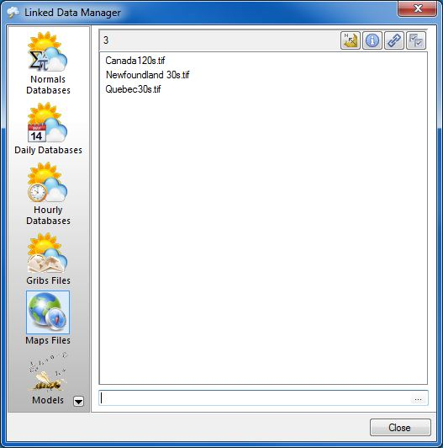

In BioSIM, input maps (DEMs) are used in two different tasks: to generate location lists and to perform spatial interpolations.

All input maps (DEMs) (files with extensions defined in the options dialog) located in one of the input map directories (global or in the project’s \MapInput\ subdirectory) are listed in the list field of the *Input Maps (DEMs)* page of the Linked Data Manager dialog. The project's \MapInput\ subdirectory is always searched first.

Buttons specific to the *Input Maps (DEMs)* page are as follows:

Envoyer_vers_ShowMap Send to ShowMap: Opens the ShowMap application and displays the map selected (highlighted) in the list field.

Afficher_l'information Show Information: Displays the selected map’s detailed information in a text editor (can be specified by the user, e.g. Notepad).

Lier_une_base_de_données Link a New File: Add the directory in which the new file is located to the linked directories list. If the extension of the new map is not in the extension list, then the extension is automatically added.

 Open Options dialog: Opens the Options dialog on the *Directories* page in which the user can add and remove links to various directories or simply see the paths to them.

Before a DEM can be linked to BioSIM, the projection information must be specified. If BioSIM does not recognize the projection of a DEM, it cannot use it. BioSIM itself does not perform changes in DEM projections. For this, other software is needed (QGIS; GDAL Translate; Arc Map).

BioSIM accepts all GDAL Raster formats (<http://www.gdal.org/formats_list.html>) as the DEM’s extension. BioSIM recommends the use GeoTIFF (.tif) formats. The Arc/Info export grid binary file format (.flt) is also supported. By default BioSIM generates output maps in the .tif format.

### Linked Data Manager, Models page

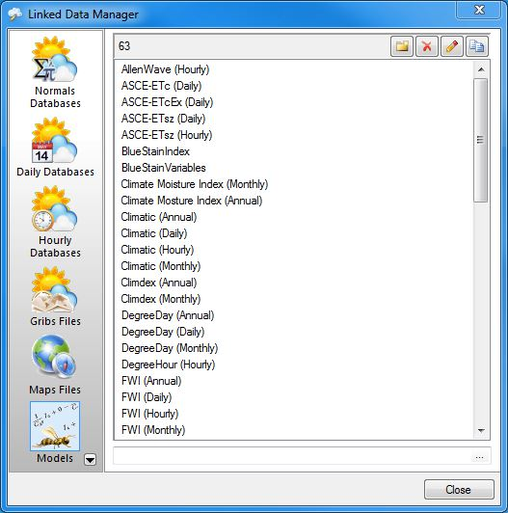The Models page lists the various models available for model execution; they are automatically stored in the software’s \Models\ subdirectory when BioSIM is installed.

If a new model (an executable file with a .exe or .dll extension) is provided by the developers, it is accompanied by a BioSIM interface file (with a .mdl extension). Copying these two files into the ...\BioSIM\Models\ subdirectory adds the new model to the model base. Often the model also comes with documentation in the form of a .pdf file. This file should also be copied into the …\BioSIM\models\ subdirectory.

New_ New: Create a new model interface to link the corresponding executable file (.exe or .dll) to BioSIM.

Delete_icon Delete: Delete a selected model interface.

Edit Edit: Edit a selected model interface through the Model Editor dialog.

Copy_icon Copy: Copy a selected model interface.

Additional models may be developed and added by the user. For instructions on how to proceed, please refer to the “Models and Model Editor” document.

### Linked Data Manager, Weather Updater page

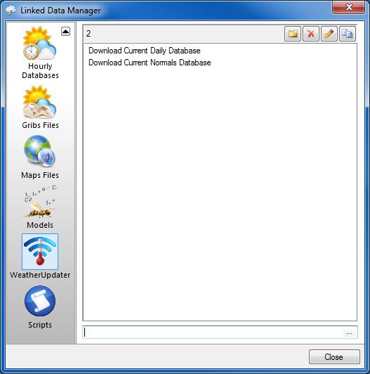The Weather Updater page lists the various Weather Updater tasks available by default in BioSIM, but a new weather updater task can be added.

All weather updater tasks (.Update) located in the update directories (in the project’s \Update\ subdirectory) are listed in the Linked Data Manager’s weather updater page list field.

New_ New: Create a new weather updater.

Delete_icon Delete: Delete a selected weather updater.

Edit Edit: Edit a selected weather updater.

Copy_icon Copy: Copy a selected weather updater.

### Linked Data Manager, Scripts page

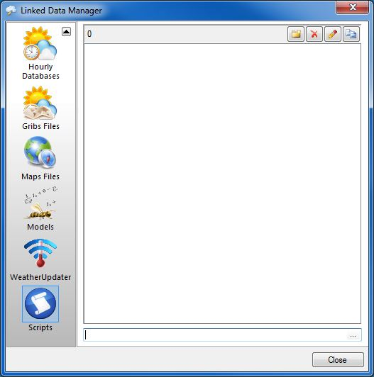The Script page helps manage script files (e.g R script file)

All Scripts located in the script directories (in the project’s \script\ subdirectory) are listed in the Linked Data Manager’s *script* page list field.

New: Create a new script file.



Delete: Delete a selected script file.



Edit Edit: Edit a selected script file.

Copy_icon Copy: Copy a selected script file.

# Groups of Components

In the Project window, select the “Project” folder icon and then click the Add Group button  on the first row of the Project window’s toolbar, or select [Project] and then [Add Group] from the menu bar. This will add a group to the “Project”.

# Defining a Weather Generation

Once suitable weather databases have been obtained and a project has been created, the next step in using BioSIM is to define at least one Weather Generation.

## Weather Generation Editor

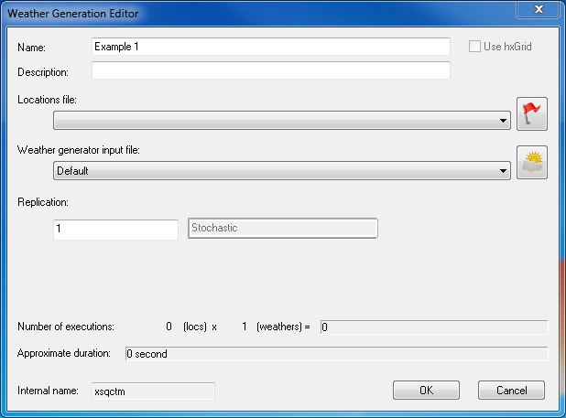Select the group you just created or the “Project” folder icon and click the Add Weather Generation button  on the first row of the Project window’s toolbar, or select [Project] and then [Add Weather Generation] from the menu bar.

Buttons and fields in this dialog are as follows:

**Name** field: Name of the weather generation to be defined (appears in the Project window).

**Description** field**:** To enter a meaningful description to be used as a reminder of the object of a weather generation or to provide additional details on the weather generation.

**Location file** field (drop-down list):Each weather generation in BioSIM is run for a series of locations (also called simulation points). This field is used to specify the list of locations for which the weather generation is to be run. The drop-down list contains all existing location lists in the \Loc\ subdirectory of the current project.

A new list can be created (or an existing list can be edited) by clicking on the  button to the far right of the field. This opens two dialogs; the Locations File Editor and the Location List Editor. Once a new location list has been created it automatically becomes available in the **Location file** field’s drop-down list and can be selected in any subsequent weather generation.

**Weather generator** **input** **file** field (drop-down list)**:** This field is used to select a set of parameters for the weather generator (which assembles a location-specific weather time). Parameter values can be the default ones or a user-defined set, saved in the project's \Model Input\ subdirectory.

To specify a new set of parameter values, or to edit an existing set, the user must click on the  button to the far right of the field. This opens two dialogs; the Weather Generator Input Manager and the Weather Generator (WG) Parameters. Once a new weather input file has been created it automatically becomes available in the **Weather generator** **input** **file** field’s drop-down list and can be selected in any subsequent weather generation.

**Replication** field: This field is used to enter the number of replications the user wants to conduct for a given weather generation.

Two things must be taken into account when assessing whether or not replication is required: the source of weather input, and the nature of the model. If a weather generation uses Normals disaggregation, it needs to be replicated. Otherwise, replication is unnecessary. When replication is required, an adequate number of replications must be estimated based on the balance between precision and processing time. These basic guidelines can be used to choose and adequate number of replications:

Minimum number of replications: 10

Commonly used number of replications: between 30 and 60

Extensive replication: 150

No number of replications provides constant output. The important thing to remember is to use a number of replications that provides what the user is ready to consider as “close enough” constancy (tolerance for differences between runs depends on the problem being studied and the user’s need for output constancy). One of the factors that can influence the variability between runs is variability of Normals disaggregation. As a general rule, the relationship between inter-run variability and the variability of an output variable can be estimated with:



where *Dr* is the inter-run standard deviation and *Dv* is the standard deviation of the output variable. A preliminary simulation may be useful to obtain an estimate of *Dv*.

## Location file

A location list is a collection of simulation points for which BioSIM can run weather generation. Location lists are managed through the Location File Manager dialog which is used to create, edit or delete them.

### Location lists file format

The file format BioSIM used for Location lists is straightforward; they are comma-separated values (CSV) files that need to contain specific column headers. CSV files are easy to generate in worksheet software (e.g. Excel, LibreOffice) using the “Save as” function. Once saved, CSV files are editable using ASCII file editors such as Notepad++. It is important to remember that the default format of CSV files can vary between computers (depending on “regional” settings). BioSIM requires comma-separated fields (values). Because a CSV file’s columns are comma-delimited, commas cannot appear anywhere within the file’s columns (such as in location names) to avoid errors when BioSIM reads these files. Also, the decimal place indicator must be a period (.), and not a comma (as is often used in French operating environments)

In each location list file, there are seven pre-set columns/variables; four are compulsory as they are necessary for the execution of a weather generation and three are optional (denoted by “\*”). The user can place the columns in whatever order. However, it is essential that the name of each header be spelled exactly as follows:

**KeyID, Name, Latitude, Longitude, Elevation, Slope\*, Aspect\*, …\***

The user may add additional columns (…\*) in the location list file. If there are any additional columns added to the regular seven, they are handled collectively as “Site Specific Information” in exports by BioSIM if the “Site Specific Information” checkbox is checked Cocher in the Export window. It is not possible to select a subset of these “Other” variables for export.

The five compulsory columns of a BioSIM location list file (KeyID,Name, Latitude, Longitude and Elevation) must never contain empty cells. This means that every location must have a value for each variable. On the other hand, the optional columns (e.g. Slope\* and Aspect\*) may be empty.

**Latitude and longitude:**

In BioSIM, latitude and longitude coordinates are always expressed in decimal degrees (DD). Latitudes south of the equator and longitudes west of the Prime Meridian are negative.

Coordinates in degrees, minutes and seconds (DMS) must be transformed into decimal degrees (DD) by applying the following transformation:

DD = SIGN(DMS) \* (ABS(D) + M/60 + S/3600)

Example:

|  |  |
| --- | --- |
| DMS | DD |
| 71 25 48 W | -71.43 |

**Elevation:**

Elevations are always expressed in meters (m).

In BioSIM, Location lists must contain point elevations. If these elevations are not known, they can be extracted from a DEM using the Extract tool  in the location list editor.

**Slope and aspect:**

Slope and aspect can influence temperature through their impact on incoming radiation. If there are no “Slope” and “Aspect” columns (or if all cells are empty, or if all values are 0), BioSIM simply does not take these attributes into account when it runs a weather generation. If the user does not have slope and aspect values in a location list but wants to use them in a weather generation, the Extract tool  in the location list editor can extract this information from a DEM. Cells with unknown Slope and Aspect values can be filled with 0’s meaning they are considered as flat terrain.

To use a location list file in BioSIM, once all the specifications mentioned above have been met, it must be saved in CSV format in the \Loc\ subdirectory of the project (each project has its own location subdirectory).

When BioSIM saves a location list modified through the Location File Manager dialog. When a location list contains site’s specific information, BioSIM places these additional columns after the five pre-set columns (KeyID, Name, Latitude, Longitude, Elevation) when it saves the file.

### Location File Manager dialog

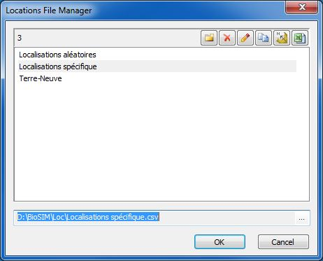

The Location File Manager dialog can be used to add, delete and edit Location list files. It contains the names of all the location lists in the project's \Loc\ subdirectory.

Buttons and fields in this dialog are as follows:

New_button_icon New: Create a new Location list file that can be edited in the Location List Editor dialog.

Delete_button_icon Delete: Delete a selected Location list file.

Edit_button_icon Edit: Send a selected Location list file to a text editor.

Copy_button_icon Copy: Copy a selectedLocation list file.

Send_to_ShowMap_button Send to ShowMap: Sends a selected location list to the ShowMap software where the locations can be viewed as points on a map.

Send_to_Excel_button Send to Spreadsheet: Sends a selected Location list file to the spreadsheet software the user previously specified in the *Links* page of the Options dialog.

**F2** key: Rename a selected Location list file.

The browse button Browse_button to the right of the read-only field at the bottom of the dialog opens the Windows Explorer and allows the user direct access to the project's \Loc\ subdirectory into which Location lists can be added, renamed and deleted.

All Location lists created using these two dialogs are saved into the project's \Loc\ subdirectory when the user clicks the OK button.

### Location List Editor dialog

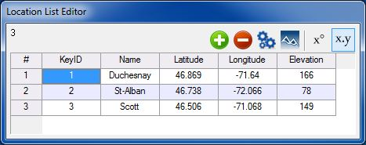The Location List Editor dialog is used to generate, edit or view a locations list in which the user can add an unlimited number of specific locations.

Buttons in the dialog’s toolbar are as follows:

 **Add point**: Add a location to the location list.

 **Remove point**: Remove a location from the location list.

* **Generate points**: Generate locations from weather stations or a DEM. Opens the Location Generator dialog.

NOTE: If this button is clicked for a location list that already contains location points, points generated using the Location Generator dialog are added to the current list (it is not overwritten).

 **Site Specific Extraction:** extract elevation, slope aspect and distance-to-shore.

 **Show in decimal degrees**: Show location coordinates in decimal degrees (DD).

 **Show in degrees minutes seconds**: Show location coordinates in degrees minutes seconds (DMS).

### Location Generator dialog

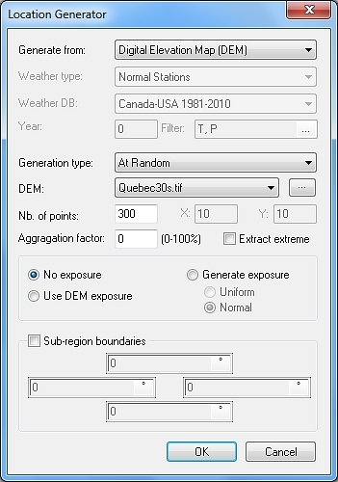

**Generate from** field: BioSIM can generate location lists from two different sources of data: Digital Elevation Models (DEM’s), or weather stations.

**Generate from a Digital Elevation Map (DEM):**

To generate a location list from a DEM, the user must select the desired generation method in the **Generation type** field’s drop-down list: “Regular Grid” (a uniform rectangular grid) or “At Random” (distributes points at random) in non-missing areas of the DEM. “At Random” is the recommended method. Next, a map must be selected from the drop-down list of the **DEM** field. BioSIM reads point coordinates, elevations and optionally exposure (slope and aspect) from the DEM

The *Input Maps* page of the Linked Data Manager dialog can be used to link new maps to BioSIM (accessed with the browse button Browse_button to the right of the **DEM** field).

**Number of points** field:Any number of points can be specified. Note that for adequate map generation, it is recommended to have n > 500. When generating a regular grid, point density in both directions is required (north-south, east-west).

### Number of points needed to obtain good mapping results

In the tutorial’s example, a small number of simulation points is specified in the Location Generator dialog to limit execution time. However, for an area the size of the province of Québec, 300 is definitively not a sufficient number of points. A number between 600 and 3000 would have been more appropriate and would have produced better results.

In determining the number of points needed, the most important factors to take into consideration are (1) the variable that is to be mapped (it is harder to spatially interpolate certain types of variables, such as precipitation), (2) the size and resolution of the input map, (3) the topography of the region being mapped (flat or complex) and (4) the number of weather stations available in the area being mapped.

When an insufficient number of points is used, the results of the spatial interpolation can be erratic. On the other hand, if an unnecessarily large number of points is used, the computation time can be excessive. Trial and error is the best method to achieve a good balance between these two constraints. A first guess can be made using the following conventions:

For a province or a state: between 600 and 3000 points.

For a large country such as Canada or the United States: between 10 000 and 30 000 points.

**Aggregation factor** field: Used to increase the density of points in mountainous regions (point density varies with topography). This is a recommended setting.

**Extract extreme** checkbox **Check**: When checked **Check**, regionally extreme elevation points (low and high) will be oversampled, at a rate of 1 point per 1600 cells.

Exposure is a combination of slope and aspect as it relates to sunlight exposure, which in turn affects daily temperature regimes (overheating of the daily maximum). If exposure values are not to be included in the location list, the “No exposure” radio button RadioButton_button must be selected. However, if exposure values are to be included, two methods are available to generate exposure:

**Use DEM exposure** radio button RadioButton_button: When selected, exposure values are computed from the elevations of the points in the vicinity of the location on the DEM. It is not recommended that location lists contain exposures at scales coarser than 1/100 000.

**Generate exposure** radio button RadioButton_button: When selected, exposure values are generated at random. There are two distributions to choose from: uniform distribution (Uniform radio button RadioButton_button), or normal distribution (Normal radio button RadioButton_button).

### Generate from a weather database:

To generate a location list from a weather database, the user must select the type of weather station from the **Weather type** field’s drop-down list (Normals stations, Daily or Hourly stations), the corresponding database from the **Weather DB** field’s drop-down list and, if needed, the filter to apply to the list of stations (using the **Filter** fields browse button Browse_button).

When using Daily/Hourly stations, the data year (e.g. 2000) for which the user needs weather stations must also be specified in the **Year** field (to include all available stations regardless of the year, specify -999 in this field).

**Generation Type**: can select between all, most complete, well distributed and complete and distributed.

**Sub-region boundaries** checkbox Check: When checked Check, the user can enter the corner coordinates (latitude/longitude) of a rectangular sub region.

### Creating a location list outside of BioSIM

**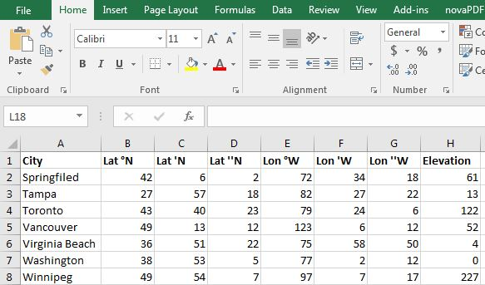**Location lists can be generated outside of BioSIM and saved as comma-delimited CSV files for BioSIM, using spreadsheet software such as Excel. Once such a list has been entered in the spreadsheet,

* All latitudes and longitudes must be converted into decimal degrees. In the decimal degree system, latitudes south of the equator and longitudes west of the Prime Meridian are negative.
* If the file does not contain elevation data, a column called “Elevation” must be added and filled with BioSIM’s missing value code (-999). Elevations can be extracted subsequently from a DEM using the Extract tool  in the location list editor. However, following extraction, the file must be checked to verify that all the elevations were extracted correctly because BioSIM will not work properly if some locations still have elevation values of -999.
* Commas or semicolons cannot appear anywhere within the file’s columns.
* The file must contain the five compulsory columns (KeyID, Name, Latitude, Longitude, Elevation) spelled exactly as shown here.

**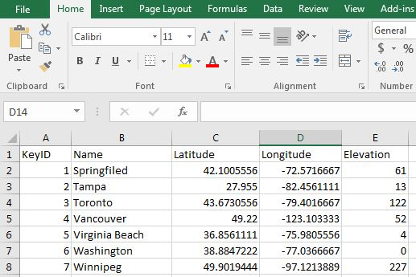**

When the file is ready to be saved, the user must select [File] [Save as] from the menu bar and select the CSV format in the drop-down list of the type field. The file must then be named and saved it in the \Loc subdirectory of the project. The user must click on Yes if an Excel dialog opens and asks:

**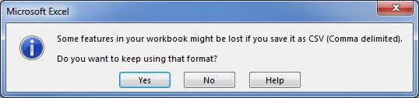**When attempting to close Excel after having saved the file in a CSV format, Excel will enquire whether the file should be saved. The user must answer Yes, because it is unnecessary to save the document in Excel format.

Example of a location list data file in CSV format

KeyID,Name,Latitude,Longitude,Elevation

1,Duchesnay,46.869,-71.64,168  
2,St-Alban,46.738,-72.066,78  
3,Scott,46.506,-71.068,149

### Extract Tools

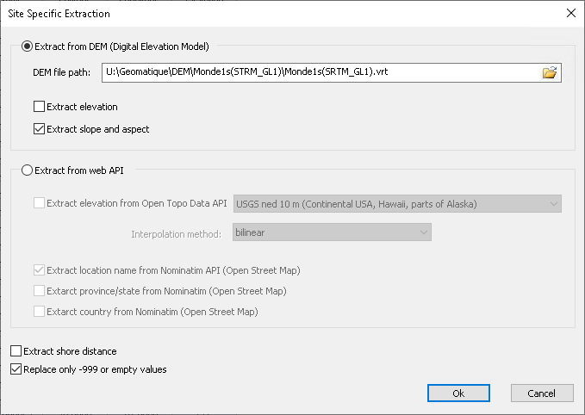Extract tools let the possibility to extract elevation, slope aspect and distance to littoral.

The extraction can be done from a local DEM or from web API.

The extraction from web API also let the possibility to extract location name, province/states and country name based on the location coordinate.

Replace only -999 or empty values let the possibility to not overwrite the location that already have information.

## Weather Generator input file

### Weather Generator Input File Manager

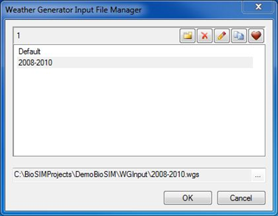

The Weather Generator Input File Manager can be used to add, delete and edit Weather input files.

New_ New: Create a new Weather input file which starts off with default parameter values that the user can then edit in the Weather Generator (WG) Parameters dialog.

Delete_icon Delete: Delete a selected Weather input file.

Edit Edit: Send a selected Weather input file to a text editor.

Copy_icon Copy: Copy a selectedWeather input file.

Set_as_default_icon Set as Default: Replace the weather generator’s current default parameter values by the values currently used in the Weather Generator (WG) Parameters dialog fields (these become the new default weather parameters used for all weather generations).

### Weather Generator (WG) Parameters dialog

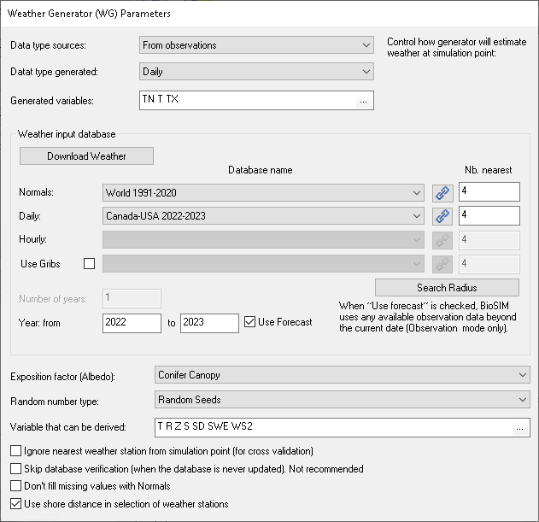**Data type sources:** to select type of data source (disaggregated data from Normals or from observations)

**Data type generated:** choose between type either hourly or daily

**Generated variables:** choose climatic variables. To add or remove variables click “...”. When the weather generation is for the purpose of execute a specific model, at least, the mandatory weather variables for this model must be generated. To do this click on select climatic variables from model. It’s also possible to manually add variables by clicking on Cocher.

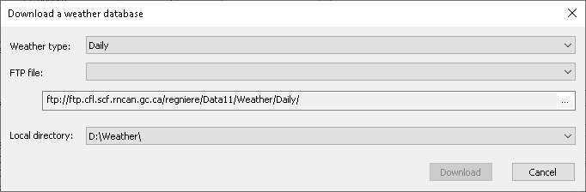**Download a Weather database**: Let the possibility to download and unzip on the fly a new weather database from FTP to local directory. If the database already exists, they will be overwritten.

**Weather type**: Choose over different type of weather. Hourly, Daily, Normals (passed), Normals (actual) , Normals (future) and Gribs.

**FTP files**: select the desired FTP weather database. Databases are split in function of region and period.

**Local directory**: Choose the local directory where the database will be unzipped.

**Normals Database name** field (drop-down list): Select the Normals database to be used in the weather generation.

**Daily Database name** field (drop-down list): Select the Daily database to be used in the weather generation.

**Hourly Database name** field (drop-down list): Select the Hourly database to be used in the weather generation.

Link_A_Database **Link a New File**: Add paths for databases (Normals, Daily, Hourly and Gribs) to the linked-path list thereby making them available in the drop-down list.

**Nb.** **nearest** field: Number of nearest stations to match with each simulation location.

**Number of years** field: This field is activated when the Normals mode is selected because certain models require more than one year of weather data. This field allows the user to enter the number of years for which to run the weather generation. Note that weather data are randomly generated from normals within a given Standard Normal Generating Period (SNGP) (e.g. 1981-2010) and that “years” are only stochastically distinct without particular annual ordering involved.

**Year from to** fields: These fields are activated when the From Observation type is selected. The user must enter the first and last year(s) for which to run the weather generation (inclusively).

Use forecast checkbox (activated only in Daily mode) Cocher: When checked, the weather generator uses forecasts available in the Daily data (instead of Normals). Data are considered “forecasts” when their date is beyond the current date.

**Exposure factor (Albedo)** field (drop-down list)**:** The user canselect “None” or “Conifer canopy” to calculate the overheating of daily maximum temperature caused by exposure to sunlight.

**Random number type** field (drop-down list): The “Always the same seed” option is used when the user wants the weather time series to be identical from one execution to the next. By default, the weather generation uses the “Random seeds” (each execution produces stochastically different weather regimes when using normals).

**Search Radius:** to specify search radius for every climatic variable in km if the value is equal to -1 it means that there is no search radius.

Four other options are available:

* Ignore nearest weather station from simulation point (for cross validation)
* Skip database verification (when the database is never updated)
* Don't fill missing values with Normals
* Use distance-to-shore in selection of weather stations

# Model Execution

Select a weather generation to which you want to add an Model Execution and click the Add Model Execution button  in the first row of the Project window’s toolbar, or select [Project] and then [Add Model Execution …] from the menu bar.

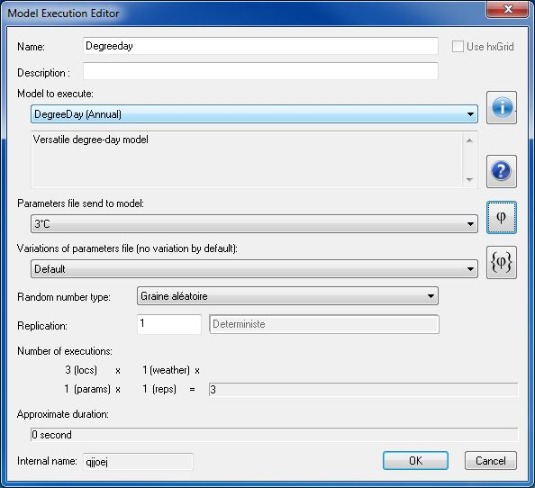

Buttons and fields in this dialog are as follows:

**Name** field: Name of the Model Execution to be defined (appears in the Project window).

**Description** field**:** To enter a meaningful description to be used as a reminder of the object of a Model Execution or to provide additional details on the Model Execution.

**Model to Execute** field (drop-down list): A list containing all the models available to BioSIM. The user must select one of these models.

The **** buttonopens the text editor and displays information about the currently selected model.

The  button open help file of the model when available.

**Parameters file sent to model** field (drop-down list)**:** This field is used to specify values of model-specific input parameters. These can either be the default parameter values provided by the model’s interface definition or a user-defined set, saved in the project's \Model Input\ subdirectory.

To specify a new set of parameter values for the model selected, or to edit an existing set, the user must click on the  button to the far right of thefield to open the Model Input File Manager dialog and the model's specific interface dialog. The identity and meaning of model parameters are model-specific.

Once a new input file has been created, it automatically becomes available in the **Model input** field’s drop-down list and is subsequently available when the same model family is selected in the **Model** field. For information on model parameters please refer to the “Models and Model Editor” document.

**Variation of parameters file** field (drop-down list)**:** This field is used to specify values of variations of parameters file input parameters.

The  button opens the Parameters Variations dialog. Occasionally, when conducting model behaviour analyses, the user can vary one or several model parameters in a model execution definition. Parameters available for this type of work are model-specific.

## Model Input File Manager

The Model Input File Manager is composed of two dialogs: the Model Input File Manager dialog (used to add, delete and edit Model input files) and a model specific interface dialog (which varies with the model selected) where model parameter values are specified.

### Model Input File Manager

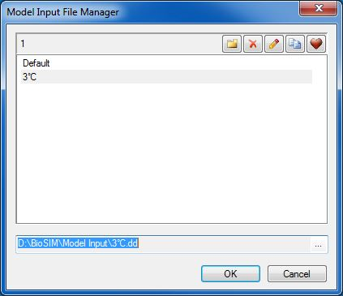

The Model Input File Manager can be used to add, delete and edit Model input files.

Buttons and fields in this dialog are as follows:

New_ New: Create a new Model input file in which the user can change the default parameter values of the model in the Model interface dialog.

Delete_icon Delete: Delete a selected Model input file.

Edit Edit: Send a selected Model input file to the text editor (for advanced users).

Modèles_copy Copy: Copy a selectedModel input file.

Set_as_default_icon Set as default: Replace the model's current default parameter values by the values currently specified in the Model interface dialog fields (these become the new default parameters used whenever this model is selected).

### Model specific interface dialog

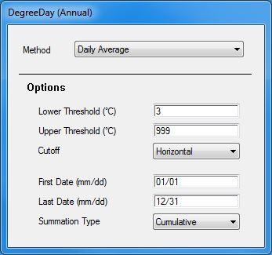

Each model in BioSIM has its own specific interface dialog. The image to the left is an example of a Model interface (in this case Degree Day (Annual)). Each field in this dialog contains a parameter that can be modified by the user. Fields can be text, integers, real numbers, Booleans (Yes/No), drop-down lists, or file names (associated with a browse button Browse). Files that are local to the project can be specified in a file name field with the [Project] keyword. For example, [Project]\Input\Deposit.dat points to file Deposit.dat in the project's \Input\ subdirectory.

To specify non-default parameter values, the user must click on the New button New_ in the Model Input File Manager dialog, type in a Model input file name, and change the desired parameter value(s) in the Model interface dialog. Clicking OK in the Model Input File Manager dialog saves the new parameter value(s) in the specified *Model input* file.

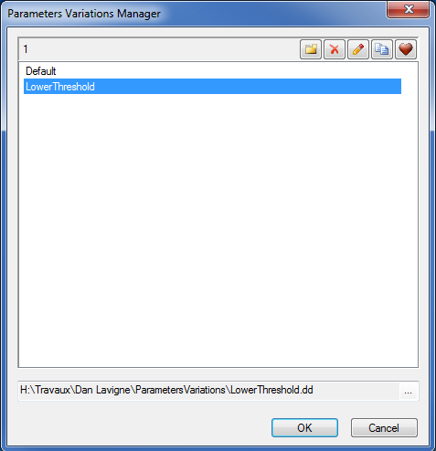

## Parameter Variation dialog

BioSIM offers the possibility of varying some numerical model parameters, singly or simultaneously, in a controlled manner within a single model execution series. This can be used, for example, in sensitivity analysis. When a parameter is varied, the entire series of model execution (locations and replicates) is repeated for each new combination of parameter values.

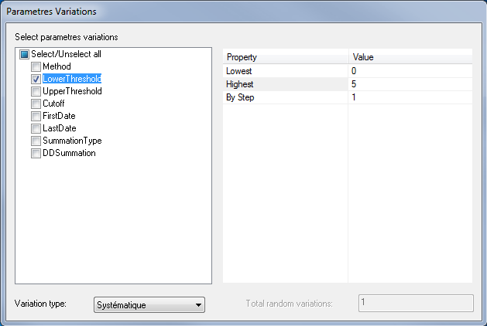**Parameters to be varied** in the right hand side list field are chosen from the model-specific parameter list appearing in the left hand side list field (**Constant parameters**) of the Parameter Variation dialog (accessed via the  button of the Model Execution Editor dialog). Each parameter selected and will be varied between a minimum and a maximum value which the user must specify in the **Minimum value** and **Maximum value** fields.

Parameter values can be varied systematically (in regular steps) or randomly.

# Defining Analyses

Once a component has been defined (even before it has been run), an analysis of its outputs can be defined. An analysis can only be run after its parent has been executed.

A new analysis of the currently-selected component (highlighted in the Project window) is defined with the [Analysis Editor dialog](#_Defining_an_Analysis). This dialog can be accessed by selecting [Project] [Add Analysis…] from the menu bar, clicking on the Add analysis button  on the first row of the Projectwindow’s toolbar, or by right-clicking on the component in the Project window and selecting [Add Analysis…] from the Pop-up menu.

The Analysis Editor dialog is composed of five tabs: *General*, *Where*, *When*, *What, Which* and *How* which collectively specify the information to be extracted from the parent component’s results.

When defining an analysis, it is often not necessary to fill out all the tabs. By default tabs in the analysis definition use defaults that correspond to the parent.

Four of the tabs (*Where*, *When*, What, Which*)* are used to filter (subset) the results from the parent component while the fourth tab (*How)* is used for calculations or transformations on the parent component’s results.

## General tab

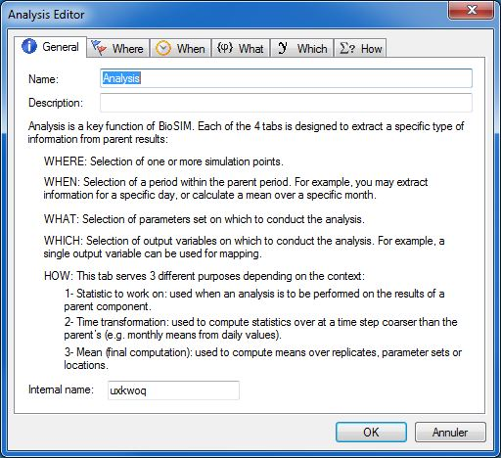The *General* tab is used to name and describe the analysis; it also provides information on the various functions performed by the other tabs of the Analysis Editor dialog.

**Name** field: Name of the analysis to be defined (appears in the Project window).

**Description** field**:** Enter a meaningful description to be used as a reminder of the object of an analysis (appears in the Execute Message log window).

**Internal name** field (greyed): An ID assigned internally by BioSIM.

## Where tab

The *Where* tab allows the user to spatially subset data from the parent component; it can be useful if output from a particular subset of locations is to beexamined.

By default BioSIM processes all locations. To select a subset of locations, the user must check Check the “Select a subset of locations” checkbox. This opens the location list used in the parent component in the *Where* tab’s list field and allow the user to select (Check) one or more locations that are of particular interest.

## When tab

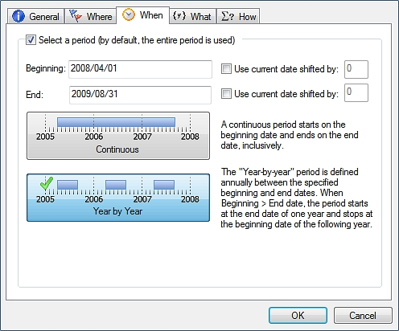The *When* tab allows the user to select a period within the parent component’s period to restrict the period covered by the analysis.

To define the period of interest, the user must check Check the “Select a period” checkbox and then use the **Beginning** and **End** fields to type in the first and last dates of the period to subset.

Depending on the parent component’s temporal mode and type, the format of dates (beginning and end) may vary. By default, if a subset is not specified, the analysis uses the entire period covered by the parent component. If beginning and end dates are entered, they must both be in the same format (e.g. year/month/day).

The Use current date shifted by checkboxes Check can be used to specify beginning and/or end dates relative to the current (system clock) date. This is a special feature that is useful when BioSIM is executed to forecast events in real-time on an automatic basis. The units of the shift are defined by the temporal type (e.g. annual, monthly, daily, hourly). In a daily type of weather generation, the number entered in the edit boxes shifts the current day by that number of days, monthly by that number of months, etc.

When defining a subset of the time period, the final step is to select the time coverage. The user has two choices:

Continuous button : By default, the *When* tab is set for coverage of a “Continuous” time period using boundaries defined by the beginning and end dates. As a result, data from the entire period covered between the beginning and end dates are used by BioSIM.

Year by Year button Year_by_Year_button: If the “Year by Year” time coverage is selected, BioSIM uses data from the period covered between the beginning and end dates on a year by year basis. Data outside the specified dates, year by year, is disregarded during computation.

NOTE: If the beginning date (month and day, excluding the year) falls after the ending date, BioSIM starts at the end date in one year and stop at the beginning date in the following year.

## What tab

The *What* tab allows the user to select a subset of parameters.

To select a subset of variables, the user must check Check the “Select variables” checkbox and then select (Check) the parameters of interest.

## Which tab

The *Which* tab allows the user to select a subset of variables. For example, to limit the number of maps created in a mapping component.

To select a subset of variables, the user must check Check the “Select variables” checkbox and then select (Check) the variables of interest.

## How tab

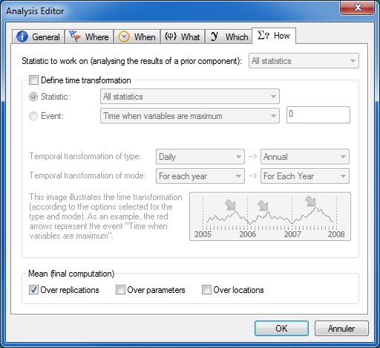

The *How* tab is the most complex tab in the Analysis Editor dialog and can be used to accomplish a wide variety of tasks involving calculations and transformations.

It is important for the user to understand that BioSIM stores results in one of two ways: either by values or by statistics. For example, weather generations and model execution store information as values and analyses as statistics. If an analysis is based on a statistical parent component (e.g. another analysis), then the **Statistic to work on** field (drop-down list) is enabled allowing the user to select a statistic to work with. For example, if the user were to select “Sum” from the drop-down list, this would instruct BioSIM to use the sum among the results of the statistical parent component.

The second part of the tab is activated when the Define time transformation checkbox is checked Check and is used for time transformation. It allows the user to transform results from one time format (e.g. daily) to another time format (e.g. annual). Each time format is composed of a type (Hourly, daily, monthly or annual) and a mode (for each year or over all years). If the “For each year” mode is selected BioSIM separates values by year before working with them. If the “Over all years” mode is selected, BioSIM uses the entire period.

The following example is meant to illustrate the difference between the “For each year” and “Over all years” options: if a model execution generated daily values from 2005 to 2008; the objective of the analysis is to transform these daily values into monthly values. If “For each year” is selected as the **Temporal transformation of mode**, the result will be 12 values per year, for each of the four years of the output, for a total of 48 values. If “Over all years” is selected, the result will be 12 values (one for each month) because the computation will be made by month, over all years.

Two types of time transformation can be performed in BioSIM: statistics or events.

When the **Statistics** radio button RadioButton_button is selected, the user can compute statistics (lowest value, mean, standard deviation, highest value, etc.). The user can choose to compute all statistics or one statistic at a time. If all statistics are computed, it is not recommended to define a final computation (see the definition below) because the sequence of computations is not always clear and unexpected results can be obtained. The 10 options available in the drop-down list are:

* All statistics (by default)
* Lowest
* Mean
* Sum
* Sum²
* Standard deviation (N-1)
* Standard deviation (N)
* Standard error
* Coefficient of variation
* Variance
* Highest
* Total Sum of Square (TSS)
* Quadratic Mean
* Range
* Nb Values

When the **Event** radio buttonRadioButton_button is selected, the user can extract an event. An event is a time at which something occurs (e.g. time when variable is maximum). In the “event” definitions below, a criterion is often needed in the event’s definition. The choices available are:

* Time when variables are maximum (default)
* Time when variables are minimum
* First time when variables >=
* First time when variables <=
* Last time when variables >=
* Last time when variables <=
* First time when cumulative % of variables > = (here, the output variable is summed up over time, and the sum is divided by the total sum)
* First time when variable >= (% of max)
* Time when variables stabilizes (tolerance …)

When an event criterion is needed, the edit box Modèles_Box_empty to the right of the drop-down list is enabled allowing the user to enter a value. For example, to determine the first time when variables are greater than 50, the event type would be “First time when variables > ” and “50” would be the event criterion.

The event or statistic is computed for all the selected variables as well as all the selected locations over the period specified for the analysis (*When* tab).

Final computations: The *How* tab has a third purpose, to compute averages over replications, parameters or locations (or any combination thereof):

When the Over replications checkbox is checked Check (checked by default), BioSIM computes the mean over all replications.

When the Over parameters checkboxis checked Check, BioSIM computes the mean over all parameter values (used when model parameters have been varied)

When the Over locations checkboxis checked Check, BioSIM computes the mean value over all locations selected in the *Where* tab.

Additional notes: The output of an analysis always depends on what is selected in the drop-down lists of the output time format of the *How* tab (output). For example, if the time period specified in the *When* tab (input) is from May 15 th to June 15 th 2011 and in the *How* tab, the output time format drop-down lists are set to “Monthly” and “For each year”, the result of the analysis is composed of two values, one computed for the 17 days specified for the month of May (15th to the 31st) and one computed for the 15 days specified for the month of June (1st to the 15th).

# Generating maps (spatial interpolation)

Mapping components are used to transform punctual results into surfaces (maps) and produce as many maps as the number of combinations of dimensions specified in their parent component (e.g. months, variables). This is why redimensioning through analysis components must be done prior to adding a mapping component. When creating a map component in BioSIM the following steps are required:

1. Adding a weather generator
2. Generating a locations list from a DEM of the area to be mapped
3. Adding a model execution
4. Adding an analysis of the variables of interest. In case of event, an extra function analysis must be add to convert time reference into Julian Day.
5. Adding a mapping component using the DEM of the area to be mapped.

The key to producing an output map in BioSIM is the generation of a suitable location list within the weather generation definition. In particular, the location list must contain a sufficiently large number of simulation points (>100) distributed more or less evenly over the entire extent of the input DEM, and covering as much as possible of its range of elevations. BioSIM’s Location List Editor is quite useful in generating such location lists, allowing to take slope and aspect into consideration. Remember that slope and aspect are not useful mapping factors at scales beyond 1/100 000 (~200m).

Through a chain of several components (e.g. analysis, merge), the user can convert outputs into a format allowing the desired mapping results (for example, to map an event date, the user needs to define an analysis and extract the event beforehand). Mapping components are most often added as a child to an analysis component. Only in rare instances can a mapping component be added directly to a model execution.

## Mapping dialog

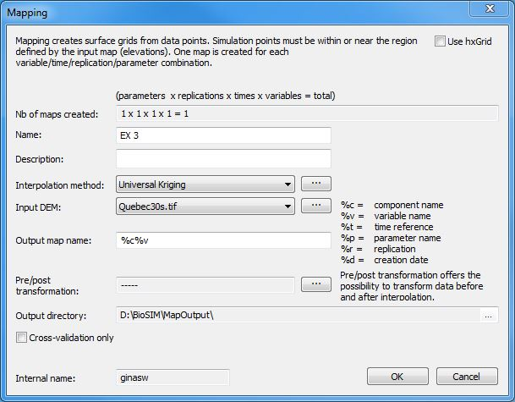

To open the Mapping dialog and add a mapping component to a project, the user can either click the Add Mapping button , select [Project] [Add Mapping…] from the menu bar, or right-click on the component in the Project window and select [Add Mapping…] from the Pop-up menu.

A mapping component is used to perform a spatial interpolation on the results of a parent component (e.g. on a weather generation, a model execution, an analysis, a function analysis, etc.) and produces as many maps as the number of different combinations between the temporal dimensions, replication, variables and parameters.

The two ingredients required for mapping with BioSIM are (1) an input DEM that has been adequately [linked to BioSIM](#_Map_Editor_dialog) (using the browse button Browse_button to the right of the **Input DEM** field), and (2) a component (usually an analysis) using locations in the area covered by the input DEM.

Mapping components can be added to a component whose output results are (1) statistical or (2) temporal (dates) (e.g. to create a map of the date at which the frequency of spruce budworm fourth larval instar is maximum, or peak L4 for short), and can be added directly on model execution or on any child component. When is an temporal results, time reference must be converted with a function analysis before to be used in a mapping, because the mapping of time references will give unreadable result.

The **Nb of maps created** field displays the total number of maps that is created by the mapping component (e.g. 12 months x 2 variables = 24 output maps).

**Name** field: Name of the mapping component to be defined (appears next to the component in the Project window).

**Description** field: A complementary description can be added to provide additional details on the mapping component for the user’s benefit.

**Interpolation method** field (drop-down list): In BioSIM, the user can choose one of four interpolation methods to map model-output features at the landscape level: Spatial Regression, Universal Kriging, Inverse Weighted Distance and Thin Plate Splines. Once a method is selected, additional options may be specified through the Advanced Mapping Options dialog accessed via the browse button Browse_button on the right hand side of this field (see below for more detail).

**Input DEM** field (drop-down list): Allows the user to select the DEM for the mapping component. DEM’s can be added using the browse button Browse_button on the right hand side of this field (see the *Input Maps* page of the Linked Data Manager dialog for more details).

**Output map** **name** field: Allows the user to enter an output map name. Because a mapping component can create more than one map, a WildCard format can be used to automatically assign names to maps. The user can choose and combine four different WildCards:

* %c: inserts the component name
* %v: inserts the variable’s name
* %t: inserts the temporal reference
* %p: inserts the value of a varied parameter
* %r: replication
* %d: creation date

Output maps are stored in the project's \MapOutput\ subdirectory, in the same format as the input DEM. Because all maps created in BioSIM are stored in the same output directory, the user must make sure all maps generated have distinct names by the judicious use of WildCards in output map names. In particular, if the %c WildCard is used, the user should makes sure to assign a different name to each mapping component so that no two maps end up with the same name. This prevents BioSIM from overwriting an existing map.

**Pre/post transformation** field: An advanced feature used to transform event data before and after interpolation.

### Transformation dialog

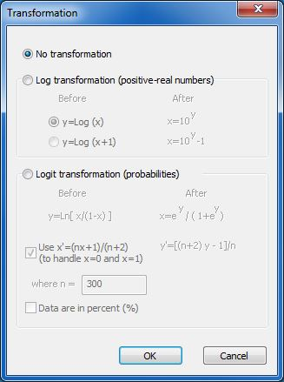

In some cases, a transformation of the output should be used prior to map making. The transformation is applied prior to interpolation, and then reversed to produce a map on the original scale. A logit transformation is useful, for example, when interpolating probabilities, so that values on the output map remain between 0 and 1.

To transform event data, the user can access the Transformation dialog by clicking the browse button Browse_button to the right of this field.

**Créer un fichier de style** : permet la création automatique d’un fichier de style (.qml) pour QGIS. Ce fichier est enregistrer avec la carte de sortie dans le sous répertoire « MapOutput ».

**Output directory** field: Shows the directory in which the output map will be stored. The browse button Browse_button to the right of this field can be used to access the project’s MapOutput directory (to see what output maps it already contains, for example).

Cross-validation only checkbox Cocher: When this is checked Cocher, only the computation of the best mapping parameters and the cross-validation R² (goodness-of-fit) of the interpolation are computed. The map itself is not created.

### Advanced Mapping Options dialog

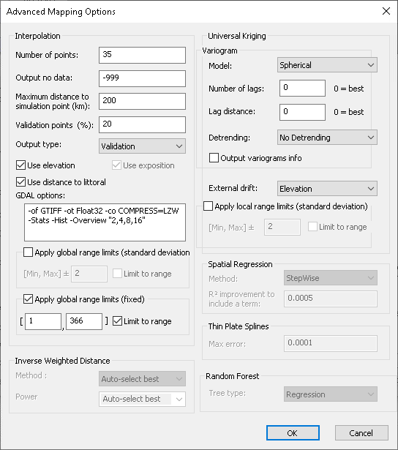

Fields in the Advanced Mapping Options dialog (accessed by clicking the browse button Browse_button to the far right of the **Interpolation method** field) are activated in accordance with the interpolation method selected in the Mapping dialog.

**Number of points** field: Number of nearest neighbours selected to perform the interpolation

**Output no data** field: Value of the missing (“no data”) value in the output map.

**Maximum distance to simulation point (km)** field: If the nearest simulation point to the computed pixel is farther than this maximum distance, then the pixel is set to missing value.

**Validation points (%)**: percent of simulation points that are use as validation set. Let the possibility to compare the performance of different interpolation method.

**Output type**: select the type of the simulations point that are show in the output table. Non selected point will be fill with missing values. 3 types are available:

* Calibration: calibration point only
* Validation: validation point only
* Calibration/Validation: both

**Apply global range limits (standard deviation)** Cocher checkbox: When this is checked Cocher, range limits are applied over the entire map (global) based on the minimum (Min), maximum (Max) and a multiplier (specified in the corresponding field) of the standard deviation of all point values. If the **Limit to range** checkbox is checked Cocher, map values outside of the range are set to the global range limits. Otherwise, they are set to “no data”.

**Apply global range limits (fixed)** Cocher checkbox: When this is checked Cocher, range limits are applied over the entire map (global) based on the minimum (Min), maximum (Max) values specified. If the **Limit to range** checkbox is checked Cocher, map values outside of the range are set to the range limits. Otherwise, they are set to “no data”.

Specifying other fields is a specialist’s task that is not recommended to the average user, and requires specific knowledge of the interpolation methods. The user should not change the default settings unless well familiar with this topic.

## Interpolation methods

### Interpolation method 1: Spatial Regression

Spatial Regression fits a multiple regression between the variable, latitude, longitude, elevation and slope/aspect. Interactions and second power terms are included. The model is simplified by removing/adding terms according to their contribution of final goodness of fit (R²). A term is included if it improves the R² by at least the amount specified in the **R² improvement** **to include a term** field of the Advanced Mapping Options dialog.

### Interpolation method 2: Universal Kriging

Universal Kriging with external drift is a commonly used interpolation method (see Deutsch, C.V.; Journel, A.G. 1992. GSLIB: Geostatistical Software Library and User's Guide. Oxford University Press, NY). Kriging is a powerful and flexible but rather complex interpolation method that requires knowledge as well as trial-and-error to produce satisfactory results. BioSIM optimizes the choice of the many options of universal kriging (variogram model, detrending method, search radius, lags, etc.). It is highly recommended that the user allows BioSIM to make these choices, but it is nevertheless possible to override BioSIM’s choices.

**Model** field: Select the desired variogram model from the drop-down list, or let BioSIM choose the best.

**Number of lags** field: Enter the number of lags, or let BioSIM find the best.

**Lag distance** field: Enter the lag distance, or let BioSIM find the best.

**Detrending** field: Usually, detrending is not necessary, but occasionally interpolation is better after detrending. By default, BioSIM applies no detrending.

**External drift** field: Choose the external drift variable(s). Most often, the drift variable of most usefulness is elevation. But other variables may be chosen, alone or in combinations of two. A useful combination may be elevation and exposure (slope/aspect) on sufficiently small map extents when exposure is part of the location list.

**Apply local range limits (standard deviation)** Cocher checkbox: When this is checked Cocher, range limits are applied to the map cell being estimated (local), based on the minimum (Min), maximum (Max) and a multiplier (specified in the corresponding field) of the standard deviation of the neighborhood point values. If the **Limit to range** checkbox is checked Cocher, map values outside of the range are set to the local range limits. Otherwise, they are set to “no data”.

### Interpolation method 3: Inverse Weighted Distance

The classical Inverse Weighted Distance (IWD) interpolation method computes the value of a variable *u* at location (*x*, *y*) by calculating the average of *N* nearby values *ui* at locations (*xi*, *yi*), weighted by the inverse of their distance *di* to the point of interpolation:

where and 

Here*, P* is a positive exponent, called the power parameter, specified in the Power field (typically, *P* = 2). The number of nearby value used in averaging, *N,* is specified in the **Number of points** field in this dialog.

A modified method, thought to produce superior interpolated surface, uses a different weight function:

 where  and *h*max is the maximum distance *h* among the *N* neighbours used in the averaging.

**Method** field: Select either Classical or Modified, or let BioSIM choose the best.

**Power** field: Select a power parameter (*P*), or let BioSIM choose the best.

### Interpolation method 4: Thin Plate Splines

Thin Plate Splines (TPS) is an interpolation method based on neighbourhood splines. Given a set of *N* neighboring points, the TPS surface is described by parameters that include 6 global affine motion parameters and 2*N* coefficients. These parameters are uniquely defined for each neighbourhood by solving a system of linear equations, and not by regression.

For more information on this interpolation method, see en.wikipedia.org/wiki/Thin\_plate\_spline. For a thorough discussion see [www.geometrictools.com/Documentation/ThinPlateSplines.pdf](http://www.geometrictools.com/Documentation/ThinPlateSplines.pdf)

## Displaying mapping results

After a mapping component is executed, the results for each mapped variable include:

* The observed values (the result of the parent component) and the estimated (mapped\_ value, displayed in the Data tab of BioSIM’s main window.
* Output maps, in the same format as the input DEM.
* The cross-validation goodness-of-fit (R²) results for each map generated by the component, displayed in the Execute Message Log window.

The resulting map(s) can be displayed by selecting the component in the Project window and choosing [Project] [Show Output Map(s)] from the menu bar, or by right-clicking on it and selecting [Show Output Map(s)]. This sends the maps to ShowMap, an independent application distributed with BioSIM.

Right-clicking again on the mapping component and selecting [Show Locations] displays the location list on the maps.

# Running components: Creating the Output Database

Once one or several components have been defined, the next step is to execute them. Components (weather generation, model execution, analyses, etc.) must be run before their results are available to be viewed and analysed. For a component to be run, it must be checked Check in the Project window.

Checked Check components can be run either by selecting [Execute Checked] [Project] from the menu bar, clicking the Execute Checked button  in the main window’s toolbar, or right-clicking on the component in the Project window and selecting [Execute Checked] from the Pop-up menu.

**NOTE:** Whenever a change is made to a component’s definition (e.g. component parameter value) or in the weather databases used for a weather generation, it is important to re-execute the component (and all there child) to update its outputs. When a component is updated, all the child components must be updated as well. To run a component and all of its child components simultaneously the user must make sure that they are all checked Check before re-executing them.

Once the checked components have been executed, the Execute Message log window displays information on each component’s last execution. This information always includes the start and end times of the component’s last execution. It also informs the user if there were any errors during execution. If the component was a mapping, the window also displays statistical information and cross-validation R².

# Examining Results

## Data

Once a component has been successfully executed, results can be viewed by selecting it in the Project window. The *Data* tab of BioSIM’s main window shows the results in tabular form, while the *Graph* tab allows the user to create and display them graphically.

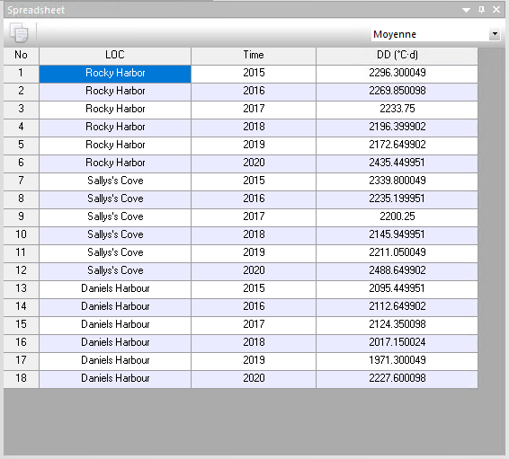The **drop-down list** in the upper right corner of the main window allows the user to choose the statistic to view in the *Spreadsheet* tab. The “Nb Values” selection in particular is useful to verify that statistics were calculated as the user intended. For instance, the user can verify if statistics were compiled from daily values or from monthly values (i.e. 365 days or 12 months).

There can be five dimensions to the results: locations, parameters, replications, time and variables. When viewing results, each of the first four dimensions is displayed in one distinct column while the “variables” dimension is displayed in as many columns as there are variables. Whenever a dimension has a single value, its column is automatically hidden. If the variable represents an event, its values are displayed as calendar dates, where format can be hourly, daily, monthly or annual with or without the year, depending on the temporal type and mode of the component.

## Exporting results

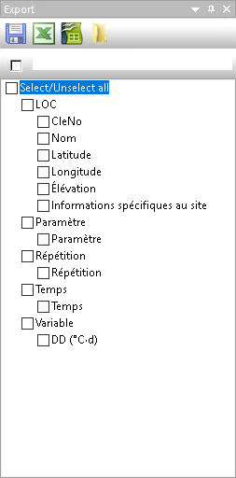The Export window contains the definition of export files (to access results outside of BioSIM).

It is possible to export results to disk () or directly to a spreadsheet (). The user can indicate to BioSIM which spreadsheet software to use by clicking on the Options button Options, or by selecting [View] [Options…] from the menu bar. This opens the Options dialog on the *Links* page in which to browse for () the preferred spreadsheet software path in the **Spreadsheet** field. If BioSIM is unable to find the spreadsheet software on the computer, a dialog appears allowing the user to browse and indicate to BioSIM where to find it.

The Export window contains the list of exports currently defined for the selected component. When a component contains pre-defined exports, the export files are over-written each time the component is executed.

Buttons and fields in the Export window are as follows:

When the Automatically export at executioncheckbox Cocher is checked, BioSIM automatically exports the results each time the component is executed.

**File name** field**:** Name of the file where the results of the export are to be stored. All exports are saved as CSV files in the \Output\ subdirectory of the project.

 Export Now: Export the results into a CSV file in the \Output\ subdirectory.

 To Spreadsheet: Export the results to disk and simultaneously send them to the user’s spreadsheet (e.g. Excel).

 To Spreadsheet II: Export the results to disk and simultaneously send them to the user’s spreadsheet II (e.g. LibreOffice Calc)

 Open Output Directory: Opens the \Output\ subdirectory of the project. In addition to exports, the \Output\ subdirectory also contains the results of analyses that are also exported as CSV files.

Format options specific to CSV files (e.g. column separators and decimal delimiters) can be specified in the *Region* page of the Options dialog.

The variables and statistics available for export depend on the model and the subsequent choices the user makes to obtain the results of the selected component.

The user can select a subset of variables (upper list field) and statistics (lower list field) to be exported. Variables and statistics to be exported can be added or removed by checking Cocher them but they are exported in the same order in which they appear (the order cannot be changed).

# Other components

## Function Analysis

To open the Function Analysis dialog and add a function analysis component to a project, the user can either click the Add Function Analysis button  on the project window’s toolbar, select [Project] [Add Function Analysis…] from the menu bar, or right-click on the component to be analysed in the Project window and select [Add Function Analysis…] from the Pop-up menu.

### Function Analysis dialog

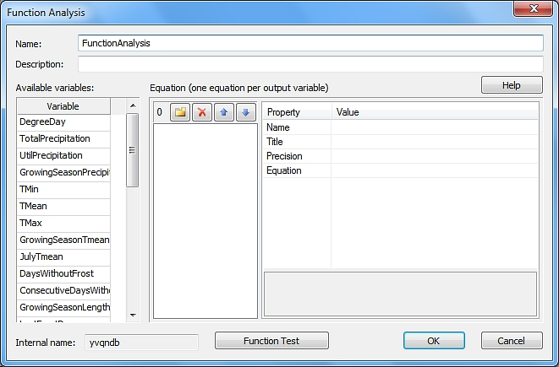

A function analysis can be used to perform logical or arithmetic operations one row at a time on the parent component’s output variables to create new variables

**Name** field: Name of the function analysis component to be defined (appears in the Project window).

**Description** field**:** Enter a meaningful description to be used as a reminder of the object of the function analysis.

**Available variables** field: Shows all the variables available for the definition of the function analysis. These are the output variables of the parent component. They are used in the formulation of the equations that define the output variable(s) of the function analysis.

**Equation (one equation per output variable)** field: To create a new variable (Modèles_New) and define it. A new variable’s name is typed-in by the user in the left hand side of the panel witch lists all the function analysis output variables defined by the user. Buttons at the top of the left hand side panel can be used to perform the following:

Modèles_New New: Add a new output variable.

Modèles_Delete Delete: Delete a selected output variable.

Modèles_up Move Item up: Move a selected output variable up in the list.

Modèles_down Move Item down: Move a selected output variable down in the list.

The right hand side panel displays the properties (definition) of the selected output variable. Fields in this panel are as follows:

**Name** field: Internal variable name, which must not contain spaces or special characters (e.g. +,-,\*,/,etc.). This is the name that is used by BioSIM to refer to this new variable. The name in the **Name** field corresponds to the name given to the variable in the left hand side panel and must be edited there and not in the right hand side panel (either by double clicking on it, or using the F2 key).

**Title** field: Text that appears in the result column header either in the *Data* tab of the main window where the results can be viewed, or in export files (text or spreadsheet) when the results are exported using the Export Now Exporter or To Spreadsheet Vers_chiffrier_ button in the Export window.

**Precision** field: The number of decimal places used to display or export results

**Equation** field: Definition of the output variable (equation). Each new variable is defined by one equation, using a combination of operators, functions, constants and input variables (those listed in the **Available variables** list). The name of a new variable cannot be used in the equation defining a second new variable (to do that, a function analysis can be created as the child of another function analysis). Each equation is typed in by the user in the Value column next to the new variable’s Equation field on the right hand side of the panel. For a complete list of the operators, functions and constants available for equations, the user can click the **Help** button.

**Internal name** field: An ID assigned internally by BioSIM to locate each component of a project.

### Analysis_Function_TestAnalysis Function Test dialog

The Function_Test button opens the Analysis Function Test dialog. It allows the user to evaluate the syntax of each new variable’s equation using numbers that are entered in the left hand side list field’s Values column and clicking the Evaluate button.

## Weather Input Analysis

To open the Weather Input Analysis dialog and add a weather input analysis component to a project, the user can either click the Add Weather Input Analysis button  on the project window’s toolbar, select [Project] [Add Weather Input Analysis…] from the menu bar, or right-click on a weather generation in the Project window and select [Add Weather Input Analysis…] from the Pop-up menu.

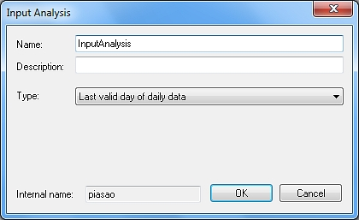An weather input analysis can only be performed on a weather generation. It is used to explore the weather inputs used in the weather generation. There are six types of weather input analyses to choose from in the **Type** field (drop-down list):

* Match stations (Normals): list the normals stations matched with each location of a weather generation. The results can be exported. The information obtained is identical to that provided by the MatchedStations application, but as a result of a component.
* Match stations (Observation): List the daily stations matched with each location of a weather generation. The results can be exported. The information obtained is identical to that provided by the MatchedStations application, but as a result of a component. Valid only in Observation mode.
* X Validation (Normals): performs a jackknife cross-validation for all weather stations in the Normals database matched to the locations of a weather generation. This is a way to estimate the error associated with the normals input.
* X Validation (Observation) (only for Observation mode): performs a jackknife cross-validation on all observed weather stations matched to the locations of a weather generation. This is a way to estimate the error associated with the observations input. Valid only on a weather generation based on Observation mode.
* Extract normals: estimates normals (using the current Normals database) at each location point.
* Number of missing observation (only in observation mode): gives the number of missing observations available in the database for each location. Provides information about how the database is up to date.
* Number of observation (only in observation mode): gives the number of observations available in the database for each location. Provides information about how the database is up to date.

**Internal name** field: An ID assigned internally by BioSIM to locate each component of a project.

## Import a File as a Component

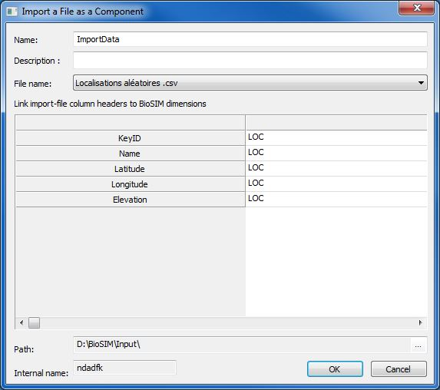External files to be imported as components can only be added to a group component. To open the Import a File as a Component dialog, the user can either click the Add Import Component button  on the project window’s toolbar, select [Project] [Add Import File…] from the menu bar, or right-click on a group in the Project window and select [Add Import File…] from the Pop-up menu.

The Import a File as a Component dialog allows the user to load external results and use them in BioSIM. This can be useful to generate a map from the imported values. The import file must be in CSV format and be located in the \Input\ subdirectory of the project.

**Internal name** field: An ID assigned internally by BioSIM to locate each component of a project.

## Merge

To open the Merge dialog and add a merge component to a project, the user can either click the Add Merge button  on the project window’s toolbar, select [Project] [Add Merge…] from the menu bar, or right-click on the appropriate group component in the Project window and select [Add Merge…] from the Pop-up menu.

The Merge dialog allows the user to merge the results of several components of the same type (e.g. analyses) to create a single component. Merging two components can be useful to export the results of several components in a single file or to perform a function analysis combining variables in different components. A merge component can only be added into a group that already contains more than one component of the same type. Only the components present in the group are available for the merge. Only one “dimension” can be joined at a time; all other dimensions must have the same size. For example, if the user wants to merge the output variables of two analyses, each analysis must have the same number of locations, parameter values, replications and would need to cover the same time period (type and mode).

**Internal name** field: An ID assigned internally by BioSIM to locate each component of a project.

## Spruce budworm dispersal

Spruce budworm dispersal let the possibility to simulation the flight of spruce bugworm by the wind with layered (3D) weather gribs. We only describe the mean idea. For more assistance communicate with BioSIM team.

**Simulation period**: period for which you want to simulate dispersal.

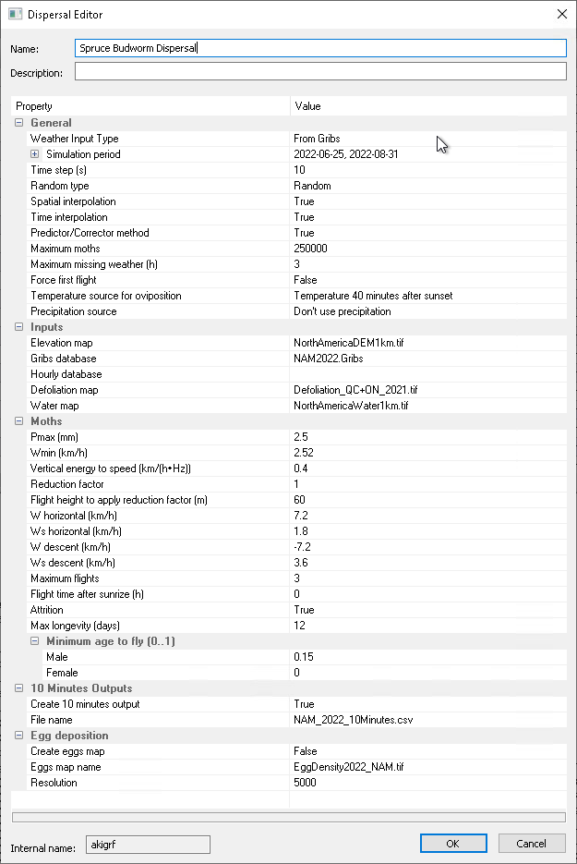**Maximum moth**: for a question of simulation time, let the possibility to limit the number of moths that flight.

**Temperature source for oviposition**: fixed at 17°C, or mean daily estimation (i.e., 42 minutes after sunset).

**Elevation map**: DEM of the region of simulation.

**Gribs databases**: gridded layered weather. This weather can be downloaded and formated by the WeatherUpdater application.

**Defoliation map**: the defoliation map determine which moth will disperse. Moth over non defoliation region will not disperse.

**Water map**: region of water. Moth that arrived in water region will dies and will not re-flight for another flights.

**Maximum flights**: number of flight that moth can do during the dispersal period.

**Flight time after sunrise**: by default, BioSIM stop the flight at sunrise. But the time of flight can be extended.

**Max longevity**: kill insect after n days.

**10 minutes outputs**: by default, BioSIM result is exported hourly. But user can also export extra file at 10 minutes resolution.

**Egg deposition**: let the possibility to create a map of all egg’s depositions. Where all females land and oviposition. Can be done once at the end of the season.

## Add curve calibration

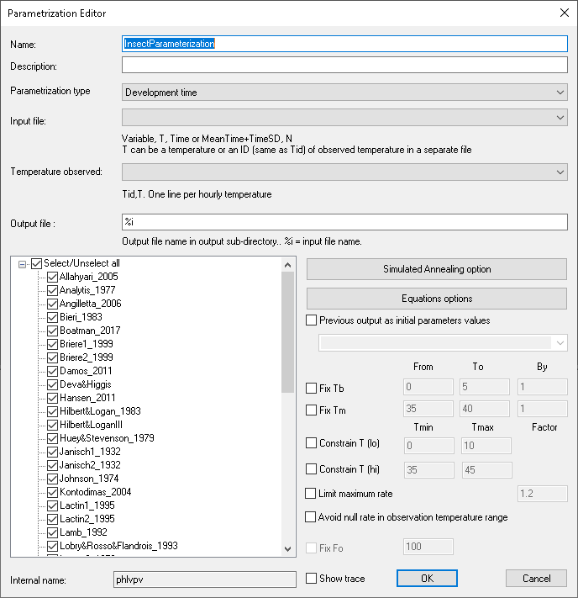

Let the possibility to fit different type of curve over biological phenomenon like development, survival, and fecundity. Also let the possibility to use different type of temperature regime like fixed temperatures, transfer temperatures and fluctuating temperatures.

**Parametrization type**: select between 3 types:

* Development
* Survival
* Fecundity

**Input file**: Input file that describe the relation between the event and the temperature. different format is used for different parametrization type. File must be in the input sub-directory of the project. Contact BioSIM team for more information and example.

**Temperature observed**: this file is used when development observation is based on fluctuating temperature.

**Output file**: Name of the output file. “%i” will take the name of the input file but output in the output sub-directory of the project.

**Equation name**: select the equation for which to want a fit. All 48 equation are selected by default.

**Simulated annealing options**: let the possibility to refine the search.

**Equation options**: let the possibility to change the default initial parameters for each equation.

**Pervious output as initial parameters values**: let the possibility to take the result of a previous run as default initial parameters.

**Fix Tb/Tm**: let the possibility to fix Tb/Tm to a specific range. BioSIM will test all combination of Tb/Tm values. These options help when the data do not correctly cover the extreme temperature range. It’s recommended to used transfer technique to cover extreme temperature. Note that all equation that don’t have Tb/Tm values will be automatically unchecked from the equation list.

**Constraint Lo/Hi**: let the possibility to force the parameters of equation to return null rate (or near zero) for a temperature range. For example, if we want to force null development between 0°C and 10°C. Avoid getting unrealistic values like -50°. For development type only.

**Limit maximum rate**: limit the maximum rate relative to the maximum observation in data. For development type only.

**Avoid null rate in observed temperature range**: avoid that equations return null rate when non-null rate is observed in dataset.

**Show trace**: for debugging purpose. Use only one equation in this case.

For more detail about equations, see document:

<https://drive.google.com/file/d/1UBbBTND2zKhsGReUBvCyhVMJ5jsDNWAx/view?usp=sharing> for development.

<https://drive.google.com/file/d/1cyHlU_eUFDlcDaX8DLLBsL2fbiGqRTMD/view?usp=share_link> for survival.

## Clean Up

The user can delete component output data, and any other files from the current project’s ...\Tmp\ subdirectory by selecting [Tools] [Clean Up Internal Files…] from the menu bar. Once this is done, component outputs results are no longer available.

## Weather updater

The WeatherUpdater application is used to create, edit, and update the weather database (hourly, daily, normals, and Gribs).

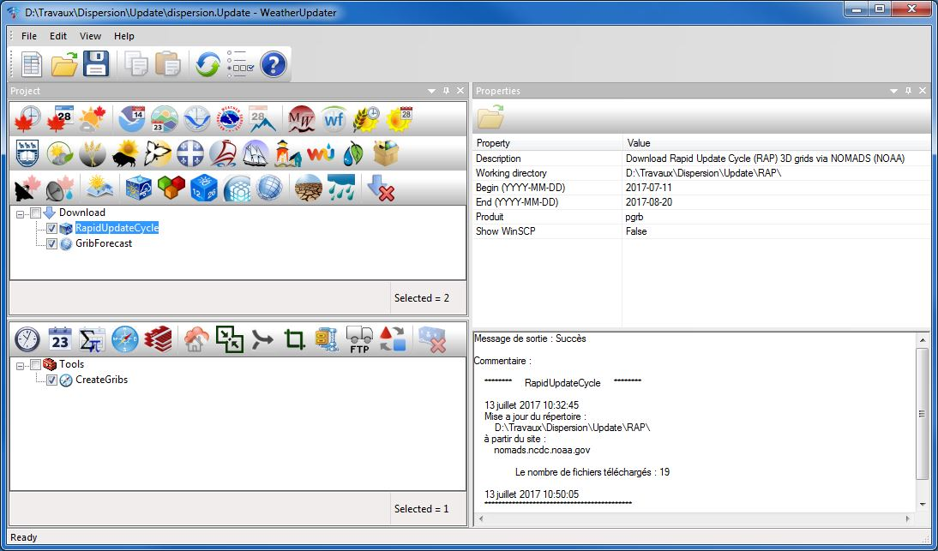To open the WeatherUpdater, click the Open WeatherUpdater button  on the BioSIM window’s toolbar.

The project window is divided into two parts. First part is to add a “download weather data” component. The second part is to create different types of database outputs (Hourly, Daily, Normal, or Gribs) from a download component. The properties window allows the user to visualize and edit the properties a component (e.g. working directory etc.).

## Daily/Hourly Editor

The DailyEditor and HourlyEditor application can be used to visualize and modify the Daily/Hourly database. To open the DailyEditor application, click the Open DailyEditor  button in the BioSIM toolbar. To open the HourlyEditor application, click the Open HourlyEditor  button in the BioSIM toolbar.

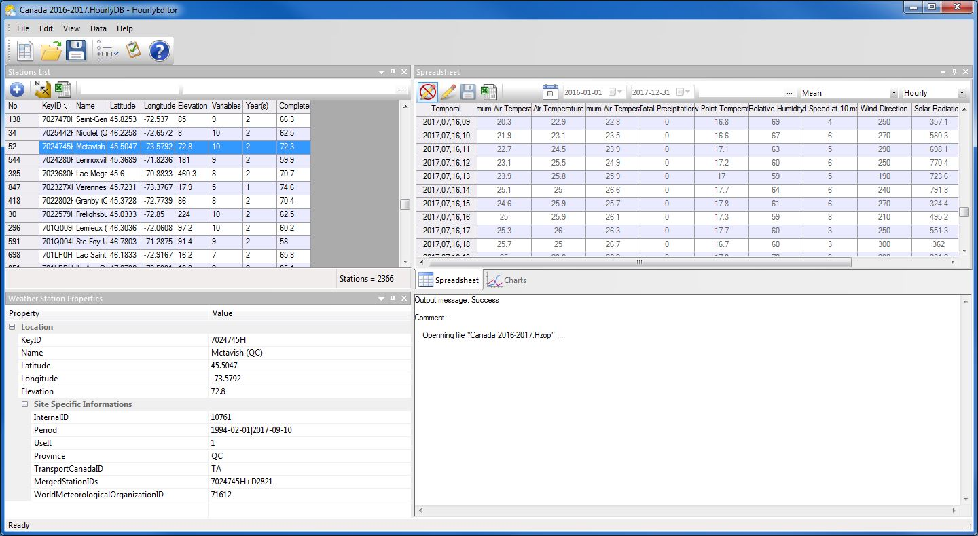

The station list window displays all existing stations in the database.

The Properties window displays information on the selected weather station. The Spreadsheet window displays the meteorological data of the selected weather station and the Charts window plots it. Data can be summarize on the fly on a hourly, daily, monthly or annual basis.

## Normals Editor

The NormalsEditor application is used to visualize and modify the Normals database. To open the NormalsEditor application, click the Open NormalsEditor  button in the BioSIM toolbar.

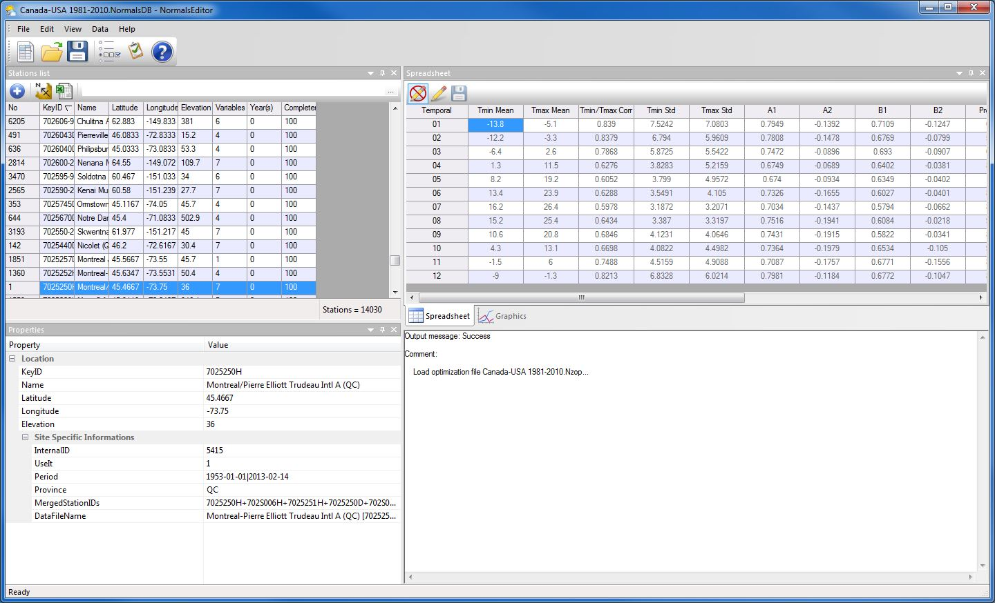

The NormalsEditor application contains the same windows as the Hourly editor such as (stations list, properties, spreadsheet, and chart).

## Weather Station Matches for Location List

The MatchStations application lists which weather stations BioSIM matches to locations in the weather generation’s location list. The search algorithm looks through the relevant weather databases and reports the stations matched in the list fields on the right hand side of the dialog. In Normals mode, only normals stations are matched. In Observation mode, both Normals and observation stations are matched to locations.

To open the MatchStations application, the user must select a weather generation in the Project window and either click the Show Matched Stations button  on the main toolbar, or select [Project] [Show Matched Stations…] from the menu bar, or right-click on it and select [Show Matched Stations…].

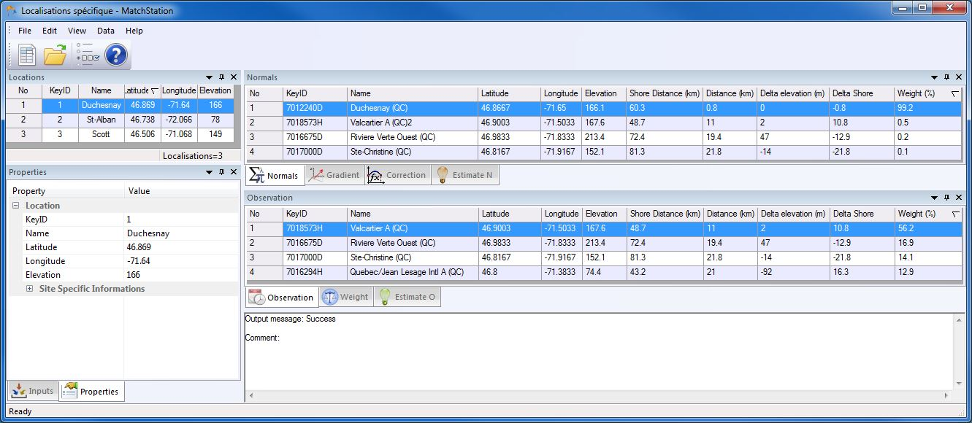

In the «Inputs» window, you can select the type of data (daily, hourty), weather, variable, number of neighbors, year you want to see the stations , the paths of the databases (Normals, Daily and Hourly) used for the weather generation.

The «Properties» window displays information (coordinates, elevation …) about the selected location.

The «Normals» window displays the information on the closest Normals stations matched to the selected location. While the «Observation» window displays the information on the closest Daily/Hourly stations matched to the selected location. Please note that for a given location, Normals and observation stations matched may differ.

Both the Normals and Daily/Hourly station list fields contain a column that displays the weight (%) each weather station has in generating weather data for the selected location (assuming there are no missing data). These weights are proportional to the virtual distance from the location. The virtual distance include a factor for elevation and distance-to-shore (when used).

Distance and elevation columns can be useful in identifying errors in the specification of locations (e.g. positive longitude in the western hemisphere).

# Models in BioSIM

Simulation models that are suitable for incorporation into BioSIM’s model base must:

* be weather-driven, accept daily minimum and maximum temperature in °C (and, optionally, precipitation in mm, dew point in °C, relative humidity in %, wind speed in km/h, wind direction in °, snowfall and snow water equivalent in mm of water, snow depth in cm, pressure in hPa, or solar radiation in watt/m²) as input, and output a series (1, 2, ..., n) of lines containing an arbitrary number of output variables;
* make no interactive requests for input;
* accept, as their sole command-line argument, the name of an input parameter specification file.

In BioSIM, models are independent applications (called executable files, with .exe or .dll extensions) that have no user interface and run without requiring interaction with the user and without output to the display. BioSIM executes each model run of a model execution task either by “spawning” the model as a child process through an operating system call to the model’s executable file, or as a call to the model’s dll. In the simplest applications, the call to the model contains a single argument: the name of a parameter file that the model’s executable must open and read.

Adapting a simulation model to meet the basic requirements of BioSIM involves some programming capabilities. While a hugely practical object-oriented base-class called BioSIMModelBase is available to perform all the required basic functions of models in BioSIM, this class has yet to be documented. It is possible to make arrangements with BioSIM developers for technical assistance in adding a model to BioSIM’s model base.

Once a model has been adapted for use in BioSIM, adding it to BioSIM’s model list is a relatively simple task. For additional details on how to edit existing models, or for instructions on how to create new models in BioSIM please refer to the “Models and model interfaces” document.

# BioSIM Options Dialog

To access BioSIM’s Options dialog the user must select [View] [Options] from the menu bar, or click the Options button Options_button on the main window’s toolbar. The Options dialog is also accessible through many of the other dialogs using either an Options button Ouvrir_le_dialogue_d'options, or a browse button Parcourir. In those instances, BioSIM has been configured to redirect the user to the relevant page of the Options dialog.

This dialog contains six pages used to specify or modify key setup information.

## BioSIM Options page

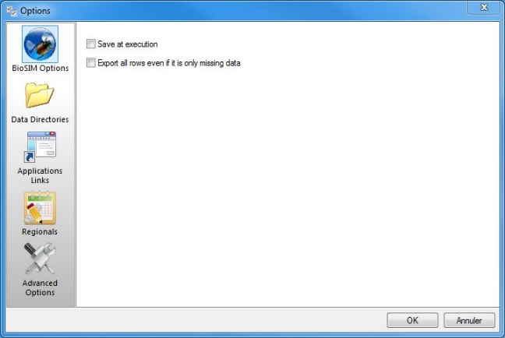

By default, BioSIM does not save the project upon execution. To have BioSIMsave the project automatically just before executing a task, check theSave at execution checkbox Cocher. By default BioSIM does not export rows containing only missing data. Check the Export all rows even if it only missing data checkbox Cocher to export all rows.

## Directories page

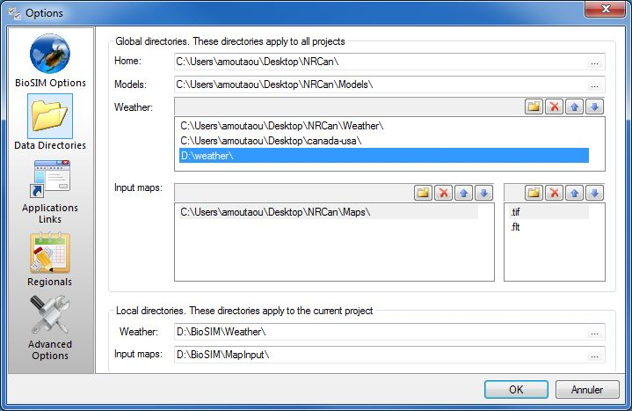In this page, BioSIM’s global and local directories (or paths) are listed. Two can be set by the user: global **Weather** and **Input maps (elevations).** The others are set automatically when BioSIM is installed (**Home** and **Models**) or when a project is opened or created (local **Weather** and **Input maps**).

The user can specify several global directories for Normals and observation weather databases by adding them in the global **Weather** directory list using the browse button (…) to the right of the list field.

Likewise, global **Input maps** directories can be added. The file format of DEM files needs to be specified by typing their extension in the second list field (on the far right). BioSIM only searches for files with extensions that appear in this list. Specific DEMs can also be linked to BioSIM through the Linked Data Manager (accessed from the main menu [Tools][Linked Data Manager], or when defining a mapping component). When such specific links are created, BioSIM automatically adds the linked DEM’s extension to the DEM format list.

** New:** to add new item

** Delete:** to delete a select item

** Move up:** move select item up

**Move down:** move select item down

In addition to global directories, BioSIM also searches for files in local project subdirectories.

## Links page

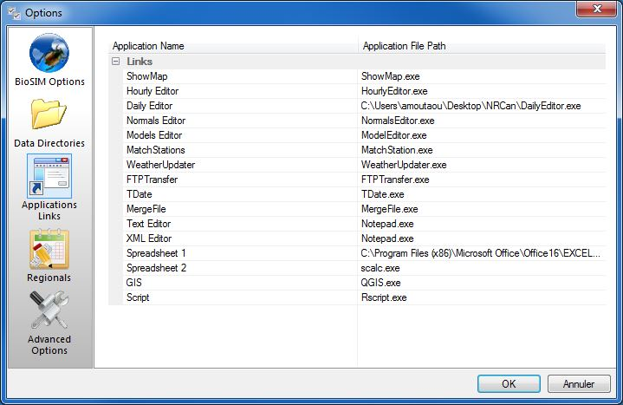

It is also useful to set the paths of applications that BioSIM can be linked to. The paths to BioSIM’s ten main peripheral programs (ShowMap, HourlyEditor, DailyEditor, NormalsEditor, ModelsEditor, MatchStations, WeatherUpdater, FTPTransfer and TDate) are set automatically and usually do not need review.

The paths to the user’s favourite spreadsheet software where results are exported (e.g. Excel) and to a text editor (Notepad.exe by default) need to be set by the user using the browse button (…).

## Region page

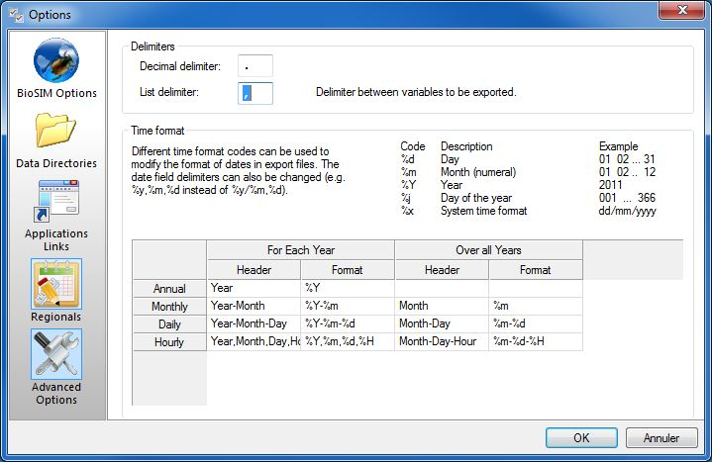

The *Region* page allows the user to modify the variable delimiters and the time variable format when exporting a file.

**Decimal delimiter** field**:** Allows the user to change the default decimal character in variables to be exported. Usually this is “.”, but in French environments it is often “,”. In that case, a list-delimiter character other than “,” must be specified in the **list delimiter** field.

**List delimiter** field: Allows the user to change the default list delimiter between variables (columns) to be exported. This is especially important in the case of French environments where “,” is used as a decimal place delimiter. A delimiter such as “;” can be used in this case.

**Time format** field**:** Allows the user to edit both the header and the format of the time variables in the “For Each Year” and “Overall Years” modes. Each time a variable is added in one of the format columns, the corresponding header must also be added in the table. The information entered in the **Time format** field table affects the way in which BioSIM displays (in the main window’s *Data* tab) and exports (in the export file) dates.

Often it is useful to have each element of a time representation exported as a separate column (e.g., year and ordinal date). In that case, the user must replace the default separator “/” by the list delimiter (as defined in the **List delimiter** field). For example, if the coma is the list delimitor, “%y,%j” outputs two columns, one for year and one for ordinal (Julian) date. The user must also remember to change the column header definition so two headers are also exported (e.g., Year, OrdinalDate).

The following list contains the most common time format codes followed by their description and an example:

|  |  |  |
| --- | --- | --- |
| **Code** | **Description** | **Example** |
| %a | Abbreviated weekday name | Thu |
| %A | Full weekday name | Thursday |
| %b | Abbreviated month name | Aug |
| %B | Full month name | August |
| %c | Date and time representation | Thu Aug 23 14:55:02 2001 |
| %d | Day of the month [01-31] | 23 |
| %j | Day of the year [001-366] | 235 |
| %m | Month as a decimal number [01-12] | 08 |
| %U | Week number with the first Sunday as the first day of week one [00-53] | 33 |
| %w | Weekday as a decimal number with Sunday as 0 [0-6] | 4 |
| %W | Week number with the first Monday as the first day of week one [00-53] | 34 |
| %x | Date representation | 08/23/01 |
| %y | Year, last two digits [00-99] | 01 |
| %Y | Year | 2001 |
| %Z | Time zone name or abbreviation | CDT |
| %% | A % sign | % |
| # | remove leading zeros (e.g. 6 instead of 06) | %#j |

## Advanced Options page

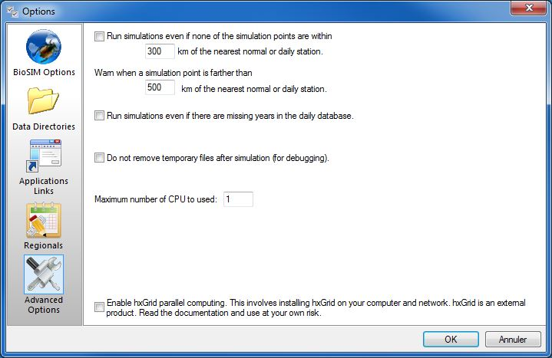While these options are often adequately set-up by default, it is good to know what they are and how they are set.

Run weather generation even if none of the simulation points are within 300box km of the nearest normals or daily/hourly station checkbox Cocher: When simulation points are farther than a given distance from the nearest source of weather data (300 km by default), BioSIM normally aborts the simulation and sends an error message to the Output Message Logwindow. The default distance can be changed, and BioSIM can be forced to run despite this situation.

Warn when a simulation point is farther than 500box km of the nearest normals or daily/hourly station checkbox Cocher: BioSIM always sends a warning to the Output Message Logwindow when simulation points are farther than a certain distance to the nearest source of weather data (500 km by default). This distance can be changed.

Run simulations even if there are missing years in the observations database checkbox Cocher: Normally, when a simulation is run using daily data and the input daily database does not contain data for one of the years required, BioSIM aborts the simulation and sends a message to the Output Message Log window. This function can be deactivated.

Do not remove temporary files after simulation (for debugging) checkbox Cocher: Because BioSIM normally removes temporary files after a run, this option could be useful for a developer who would want to see the temporary input and output files of a run.

Maximum number of CPU to used: to specify the maximum number of CPUs to use when a simulation is run (BioSIM uses parallel-processing capabilities)